Name _________________________________________ Date __________ Block ___________

Unit IV TEST
Weather & Climate
Review

- The Atmosphere

1. The distance above sea level.

2. The result of the weight of a column of air pushing down on an area.

3. An instrument that measures changes in air pressure.

4. The condition of the Earth’s atmosphere at a particular time and place.

5. The layer of gases that surrounds the planet.

6. What four main gases are found in our atmosphere:

7. In what ways does our atmosphere make conditions on Earth suitable for living things:

8. What are the main causes of weather:

9. All weather occurs in this layer of the atmosphere:

10. Air pressure is the highest at this location:

11. The ozone layer is located within this layer of the atmosphere:

12. The ionosphere and the exosphere are both located within this layer of the atmosphere:

13. Lines of equal pressure are called:

14. We live out our lives within this layer of the atmosphere:

15. Low air pressure indicates what type of weather:

16. High air pressure indicates what type of weather:

17. Altitude affects both density and air pressure in these ways:

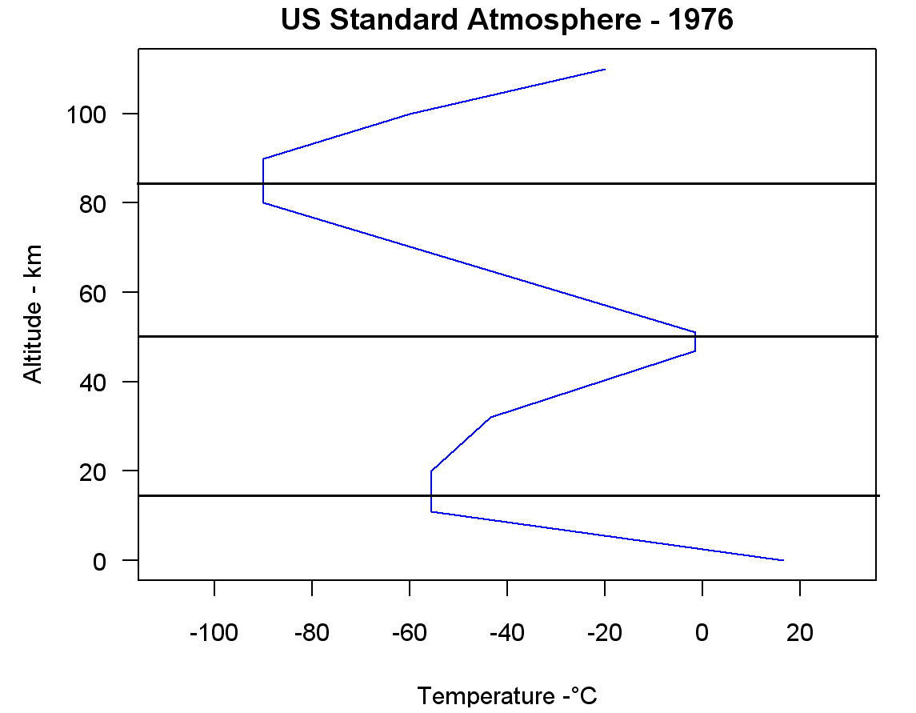
Identify the layers of the atmosphere:

A.

B.

C.

D.

The coldest layer of the atmosphere is the:

At 18km above Earth’s surface, the temperature would be about:

At what altitude would you find the temperature to be about -90°C?

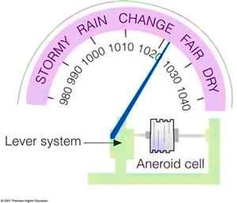

High pressure reading would fall within this range:

Low pressure reading would fall within this range:

If I had a pressure reading of 990mb, what type of weather
could I expect to see outside?

What type of pressure system is sitting
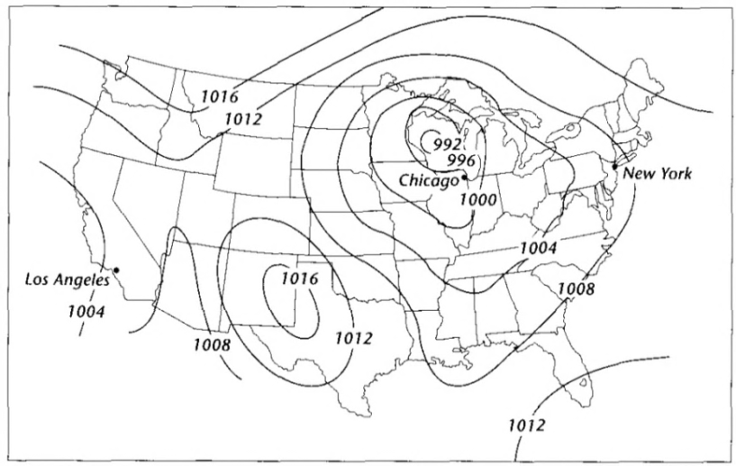
over Chicago?

What type of weather would Chicago be
experiencing?

Los Angeles falls within this pressure range:

- Wind
28. Wind

29. Local Wind

30. Global Wind

31. Coriolis Effect

32. Jet Streams

33. Winds are described by:

34. Calm winds at the equator are called:

35. In the Northern Hemisphere winds curve to the:

36. The closer isobar lines are to each other means:

37. The farther isobar lines are to each other means:

38. Factors that cause the unequal heating of Earth’s surface are:

39. All wind is caused by differences in:

40. Land breezes and sea breezes are both examples of:

41. These winds blow between the poles and 60° N & S, and are extremely cold but weak:

42. These winds occur between 30° N & S and have calm to no winds:

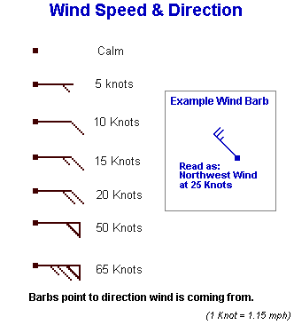
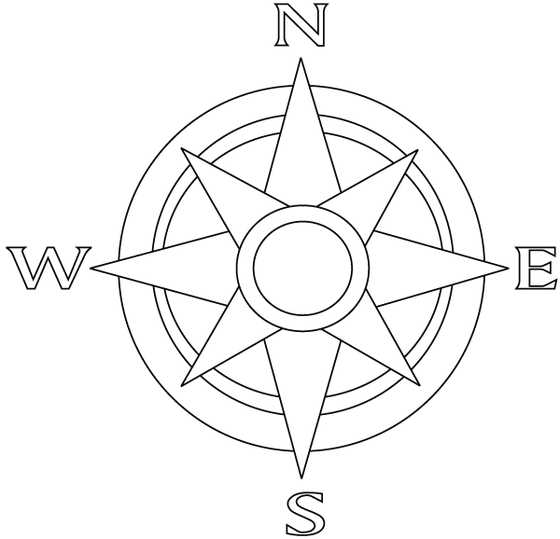
43. Direction:
Speed:

44. Direction:
Speed:

45. Direction:
Speed:

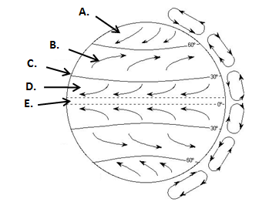
Label each of the wind zones:

46. Trade Winds

47. Horse Latitudes

48. Doldrums

49. Prevailing Westerlies

50. Polar Easterlies
_________________________________________________________________________________

- Water
51. Hydrosphere

52. Humidity

53. Evaporation

54. Condensation

55. Precipitation

56. Describe the characteristics of a:
a. cold air:

b. warm air:

57. Oceans, lakes and rivers are all examples of:

58. Of all the water on Earth, only this percentage is available for domestic use:

59. The water cycle is powered by:

60. The loss of water through the leaves of plants is called:

61. Evaporation occurs due to:

62. This always comes from clouds:

63. Nimbostratus means ____________________ and forms this type of clouds
_________________________________

Label the diagram of the water cycle:
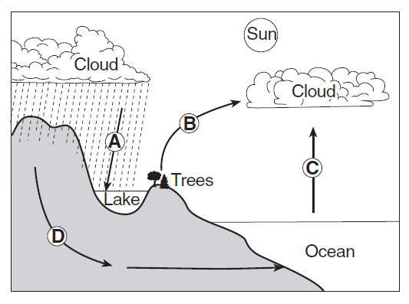
A –
E
B –

C –

D –

E –

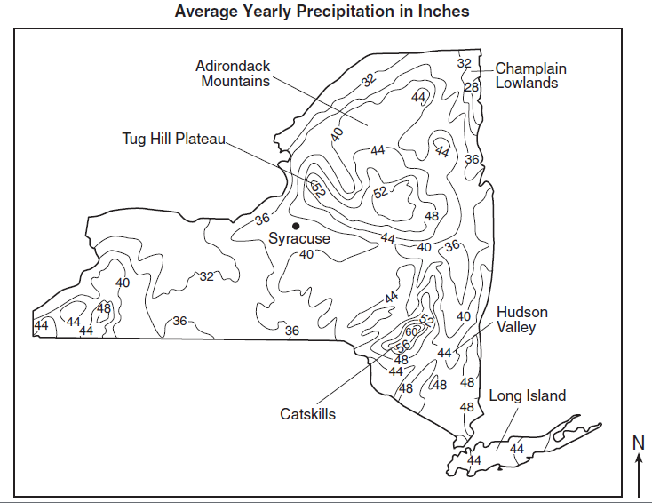
What precipitation range does
Champlain Lowlands fall within?

How much annual precipitation does
Hudson Valley receive?

What units are used to measure
precipitation amounts?

What would be an acceptable estimate
for the amount of precipitation that
Syracuse receives?

Dry Bulb  (F) | Wet Bulb  (F) | Depression | Relative Humidity  (%)
80 | 70
52 |  | 5
 | 92 | 8
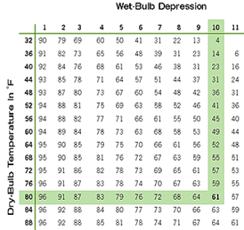

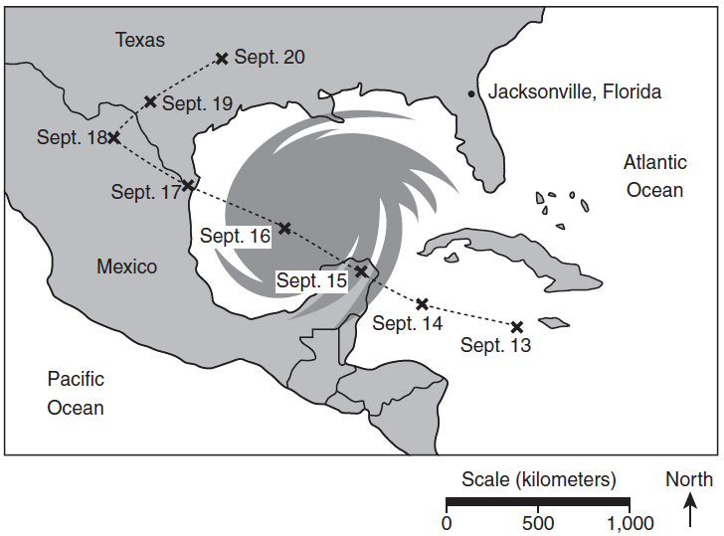
What weather event is taking place in the diagram
to the right?

On what date did this event begin to be tracked?

On what date did this event stop being tracked?

On what two dates did this event hit land?

- Weather Patterns

76. Air Mass

77. Front

78. Cyclone

79. Anticyclone

80. Storms

81. Air masses are classified by:

82. Hot and Wet air masses:

83. Hurricanes and tornadoes are both examples of:

84. Cold and Dry air masses:

85. This scale is used to categorize tornadoes: _______________________________

- It is based on ________________________ and ________________________

86. Stationary Front:.

87. The cause of most human suffering and death:

88. Weather moves from ______________ pressure to ______________ pressure.

89. Thunderstorms and tornadoes are both associated with _____________________ clouds.

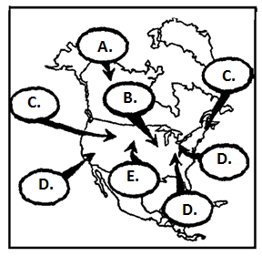
What type of air mass is:
90. A -

91. B -

92. C -

93. D -

94. E –

________________________________________________________________________________

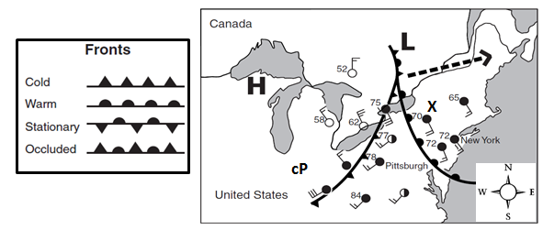

What direction is the Low Pressure system moving?

What is the wind speed at X?

What is the temperature in Pittsburgh?

What type of front is headed toward New York City?

What direction is the wind blowing from in Pittsburgh?
[Type a quote from the document or the summary of an interesting point. You can position the text box anywhere in the document. Use the Drawing Tools tab to change the formatting of the pull quote text box.]

V. Climate
The loss of the protective ozone layer that filters harmful UV radiation coming from the sun:

The distance from the equator, north or south:

The average, long-term, conditions of an area:

Gases in the atmosphere that trap solar energy and keep the Earth warmer than it should be:

The condition of Earth’s atmosphere at a particular time and place:

Climate is affected by these two factors:

The farther North or South you go, the colder the temperature gets due to:

In the case of high mountains, this is the most important climate factor:

Natural factors of climate change are all of the following:

This is also often called the “Rain Shadow”

Marine climates are usually _____________ in the summers and _____________ in the winters.

Continental climates have _____________ temperatures due to the distance away from oceans.

Marine air masses are usually _____________ and continental air masses are usually _____________.

The last ice age ended about _____________ years ago.

It is believed that we are currently living in an _____________ period right now.

This climate zone has temperatures ranging from warm summers to cold winters:

The side of the mountain faces the wind and receives a lot of rainfall.

This climate zone receives the least amount of solar radiation and therefore has the coldest climate.

The side of the mountain facing away from the wind and receives little rainfall.

This climate zone receives direct sunlight all year round.

- Making Connections – Use the diagrams to answer the questions that follow.
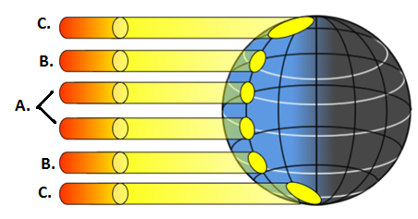

Tropical Zone -

Temperate Zone -

Polar Zone -

