Name ____________________________________________ Date _________ Block _________

**Unit V**

**Earth’s Changing Surface**

**Review Sheet**

1. **Mapping Earth’s Surface**

* Map -
* Globe -
* Hemisphere -
* Elevation -
* Relief -
* Earth’s 4 spheres:
  + Earth’s solid rocky outer layer:
  + All living things:
  + Earth’s gas layer:
  + Earth’s water:
* How many meridian lines are found on the globe?
  + Every meridian line represents:
* Lines that connect points of equal elevation are called:
* Which part of the diagram to the right represents the:

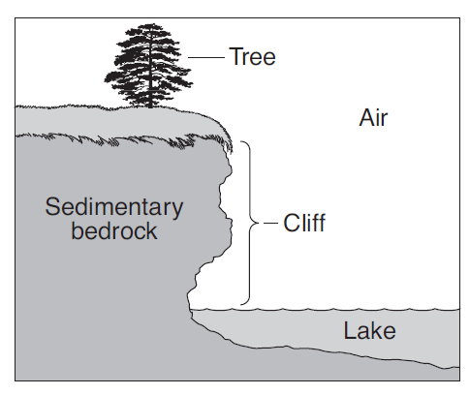 a. **Atmosphere:**

**b. Hydrosphere:**

**c. Lithosphere:**

**d. Biosphere:**

**C**

**B**

**A**



**D**

**E**

**F**

**1.**

**5.**

**3.**

**4..**

**2.**

* What letter represents:
  + Prime Meridian
  + Equator
  + Northern Hemisphere
  + Southern Hemisphere
  + Eastern Hemisphere
  + Western Hemisphere
* What are the coordinates for:
  + **#1**
  + **#2**
  + **#3**
  + **#4**
  + **#5**
* If it was **8pm at #3**, what time would it be at:
  + **#1**
  + **#2**
  + **#3**
  + **#4**
  + **#5**
* 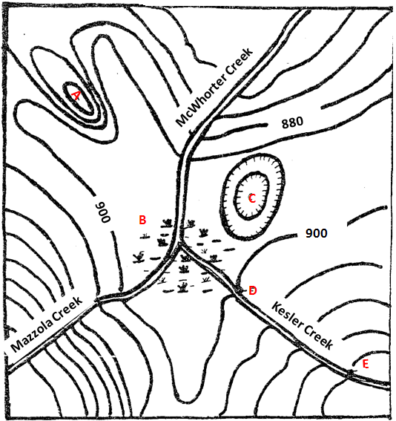What is the contour interval of this map?
* What would the elevation of **C** be?
* What would the elevation of **A** be?
* What is the symbol at **B**?
* What is the symbol at **C**?
* Which creek has the **steepest gradient**?
  + How do you know?
* Which creek has the **most gradual gradient**?
  + How do you know?

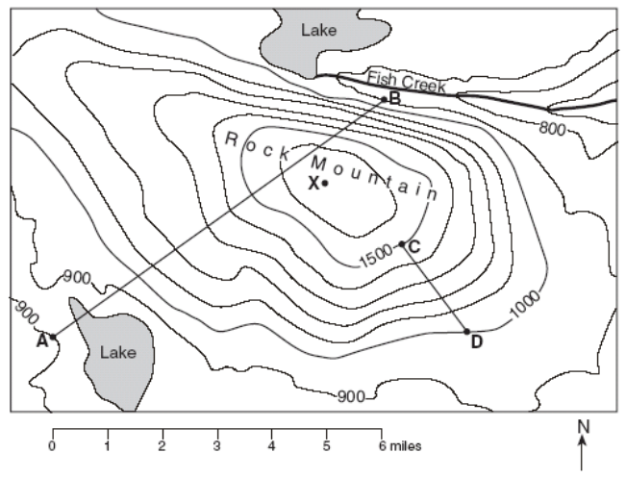

1. What is the elevation at:

A: __________ B: __________ C: __________ D: __________

1. What is the contour interval of this map? _________________
2. What is the **gradient** between points **C and D**?

Formula:

Work:

Answer:

_____ 4. Which profile would best represent the image above between points A and B?

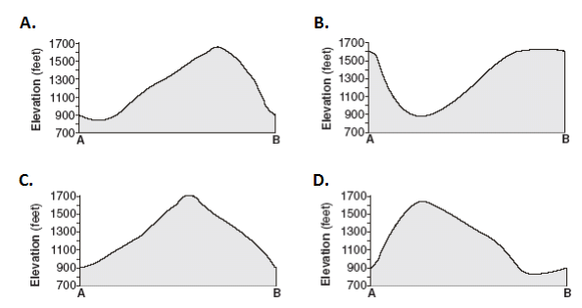

**Topographic Profile** – complete a topographic profile for the map below.

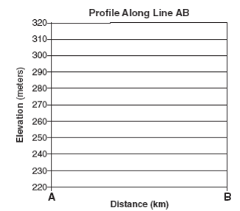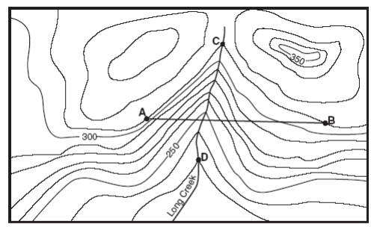

1. **Plate Tectonics**

* The hypothesis that the continents slowly moved across Earth’s surface -
* A break in Earth’s crust where slabs of rock slip past each other -
* The process by which molten material adds new oceanic crust to the ocean floor -
* The name a the single landmass that existed 200 million years ago; “all lands” -
* A device that determines the distance of an object under water by recording echoes of sound waves –
* The theory that pieces of Earth’s lithosphere are in constant motion -
* The driving force of lithospheric plate movement is:
* The lithosphere, asthenosphere and mesosphere all make up this layer of Earth:
* Iron and nickel make up the:
  1. 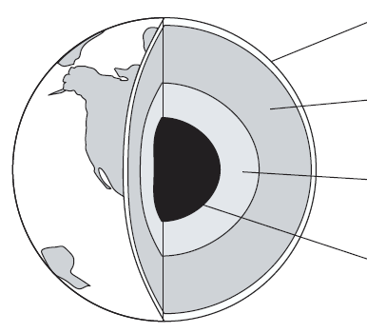**Label the Diagram**

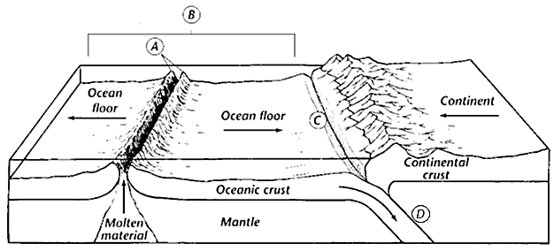

* What does **A** represent?
* What process does **B** represent?
* What does **C** represent?
* What process **D** represent?
* What type of boundary is happening at **C**?
* What type of boundary is happening at **A**?
* 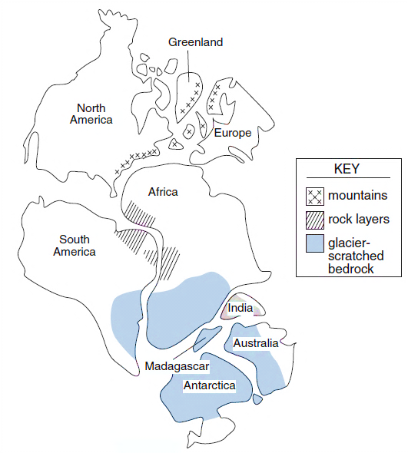Which type of crust is most dense?
  + How do you know?
* What evidence shows that
  + Antarctica and Australia were once connected?
  + North America and Greenland were once connected?
  + Greenland and Europe were once connected?
  + South America and Africa were once connected?

1. **Earthquakes and Volcanoes**

* Seismic Waves
* Epicenter
* Magnitude Scale
* Liquefaction
* Focus
* The fastest seismic wave and can travel through solids, liquids and gases:
* A mountain of water created by an earthquake in the ocean floor:
* An S Wave can only travel through:
* Smaller earthquakes that occur after a larger earthquake in the same area:
* P Waves travel at:
* S Waves travel at:
  1. **Understanding Diagrams** – Use the diagrams to answer the questions that follow.
* Identify the type of seismic wave each diagram represents:

**Primary Wave (P) Secondary Wave (S) Surface Wave (L)**

1. B. C.

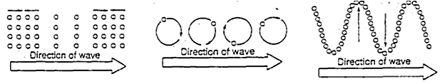

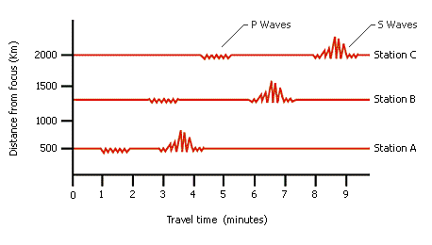

* How long did it take the **P Wave** to travel to **Station C**?
* How long did it take the **S Wave** to travel to **Station C**?
* What would be the **S-P Interval** for **Station C**?
* How far did the **P Waves** travel before they reached **Station B**?
* The farther away from the epicenter you travel, what happens to the S-P Interval?
* Would Station A, Station B, or Station C receive the least damage from this earthquake

and why?

Label the diagram of the earthquake:

**Focus Epicenter Fault Seismic Wave**

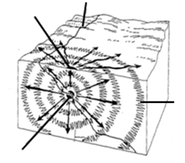

Define:

* Aa
* Pahoehoe
* Pyroclastic Flow
* Lava
* Magma
* Thick, sticky magma that gets stuck in the pipe of a volcano and plugs it is a characteristic of this type of volcano:
* Runny, free flowing lava is a characteristic of this type of volcano:
* Most of Earth’s active volcanoes are located:
* Stationary openings in the mantle where magma melts through the curst:
* Other types of volcanic activity that do not involve the eruption of lava are:
* How does the content of silica affect magma:
  + **High Silica**:
  + **Low Silica**:
* Yellowstone National Park is an example of a:
* Mount Rushmore is an example of:
* A volcano that is expected to become active in the near future is called:
* A Volcano that is never expected to erupt again is called:
* A volcano that is currently erupting:

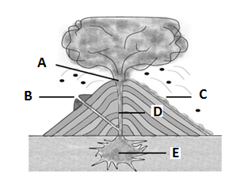

Identify the parts of a volcano:

* Side Vent:
* Lava:
* Pipe:
* Magma Chamber:
* Crater:
* What type of volcanic eruption

does this best represent?