Name _________________________________________ Date __________ Block ___________

Unit III Review Sheet
Energy & Heat

- Energy

- Nonrenewable energy resources that form in the Earth’s crust over millions of years.

- A natural resource that can be used and replaced over a short period of time.

- The ability to cause change or make things move.

- Natural resources that cannot be replaced quickly or at all.

5. Any substance, organism or energy form that living things use.

6. Trees, Fossil fuels, Wind, Water and Sun are all examples of:

7. The primary source of all energy is the:

8. The sun’s energy allowing a carrot to grow is what type of energy conversion:

9. List some examples of a renewable resource?

10. Petroleum, natural gas and coal are all examples of:

11. Eating ice cream and then riding a bike would be an example of this type of energy
conversion.

12. Using an electric stove to boil a pan of water is an example of this type of energy
conversion.

13. Kinetic energy is _______________ greater than potential energy.

14. Trees, water, wind and sun are all example of this type of resource.

15. What does the Laws of Conservation of Energy state?

16. Velocity has the greatest effect on an object’s _______________________ energy.

- Use the diagrams to answer the questions that follow.

17. What form of energy do each of the following images best represent?
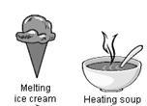
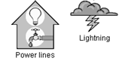

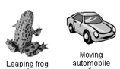
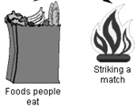

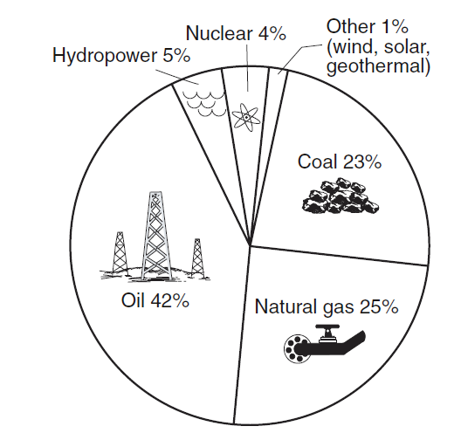
17. Name two energy sources that when combined
provide less than 10% of the total energy used in
the United States.?

18. What energy sources are examples of renewable
resources?

19. What energy sources are examples of nonrenewable
resources?

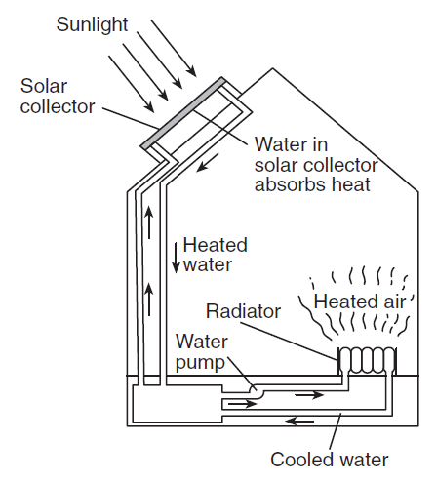

20. What is the original source of energy for this
heating system?

21. What energy conversion would this heating
system best be demonstrating?

- Electricity & Magnetism

22. Atom

23. Force of Attraction

24. Force of Repulsion

25. Ion

26. Conduction

27. Electrons are located on the __________ of an atom and have _____________ charges.

28. The Rule of Electric and Magnetic Charges states:

29. The electric field of a charged particle is strongest farthest from the particle.

30. When an atom loses an electron it becomes:
a. Why?

31. This type of material permits the flow of electric charges freely:

32. Atoms that have equal numbers of protons and electrons are called:

33. When a material has its electrons all pointing in the same direction it is said to have:

34. Most homes have their electricity wired with these circuits:

- Use the diagrams to answer the questions that follow.

Positive Ion Negative Ion Electrically Neutral

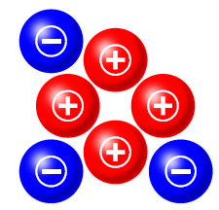
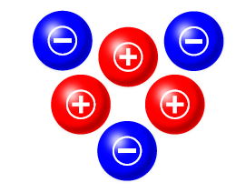
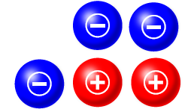
A. B. C.

- B.
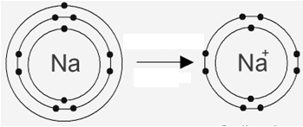

38. What type of atom does image A best represent?

39. What type of atom does image B best represent?

40. If picture B has 11 electrons, how many protons would picture B have?

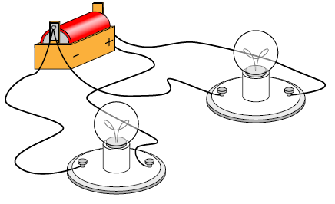

41. What type of circuit does this best represent?

42. Why is a house hooked up with this type of circuits?

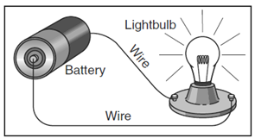

43. What type of circuit is pictured to the right?

44. Why will the light bulb be lit with the situation as
It appears in the diagram?
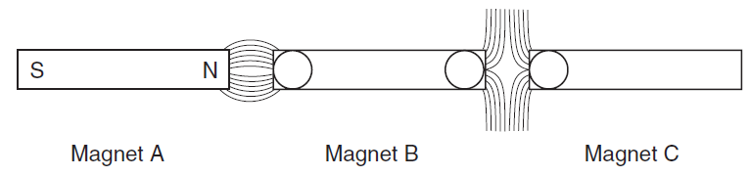
A B C

45. According to the diagram above, the correct order of the poles labeled
A, B and C are:

46. According to the diagram, which two magnets are attracting each other?

47. Which two magnets are repelling each other?

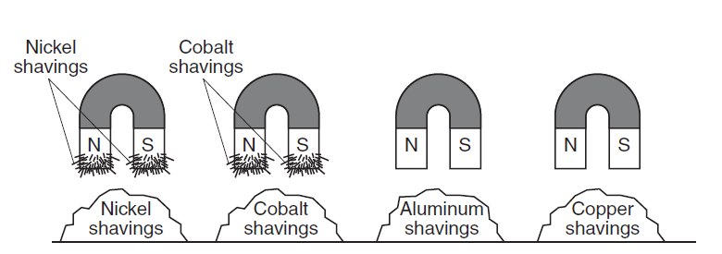

48. In the diagram above, which two metals have magnetic attraction?

49. Which image would show magnets with the weakest magnetic attraction between
them?
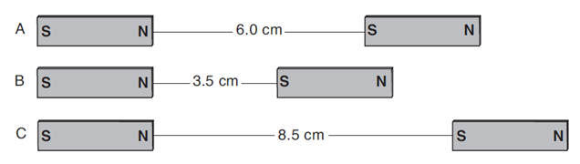

III. Heat

50. The amount of heat needed to raise the temperature of 1g of a substance 1°C.

51. Any substance that does not permit the flow of heat or electricity easily.
52. The total energy of particles of a substance or material.

53. The amount of heat needed to raise the temperature of 1g of water 1°C.

54. Any substance that permits the flow of heat or electricity freely.

55. A chemical change that absorbs heat, has a final temperature greater than its
initial temperature and has a positive kinetic energy is called an:

56. Heat transfer by direct contact:

57. Heat transfer in fluids; liquids and gases:

58. When a substance/material gains heat what happens to its:
a. Volume:
b. Density:

59. Define: Thermal Expansion -

60. Heat always moves from ________________ objects to ______________ objects.

- Use the diagrams to answer the questions that follow.

Liquid Gas Solid

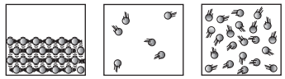

A B C

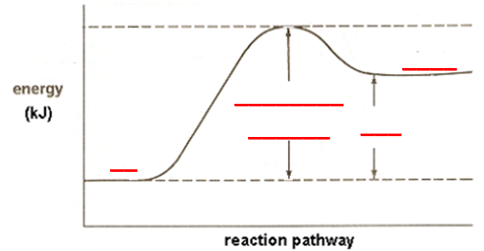

61. Label the diagram above.

62. What type of reaction is being pictured above?

63. Name two process that would be an example of this type of reaction:
a.
b.

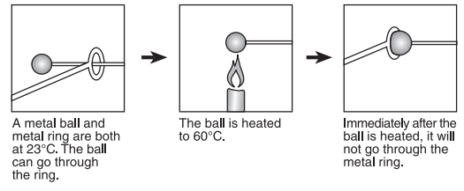

64. What is the name of the process that took place in the diagram above?

65. How is the volume of the ball affected?

66. How is the density of the ball affected?

67. Would heat be gained or lost?
a. This type of reaction is called:

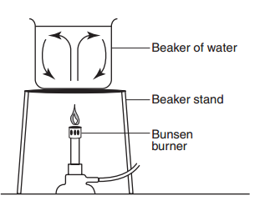

68. What type of heat transfer is taking place inside the beaker of water?

69. What type of heat transfer is taking place between the bunsen burner and the
beaker stand?

70. What type of heat transfer is taking place between the beaker stand and the
beaker of water?

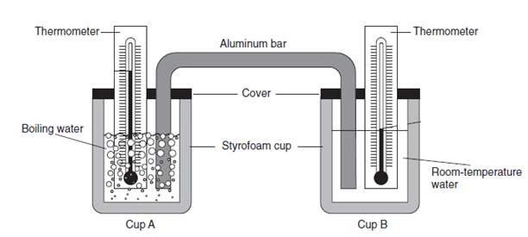

71. What type of heat transfer would best be represented in the diagram above?

72. The aluminum bar is an example of a:

73. The Styrofoam cup is an example of an:

74. Heat will transfer from cup _______ to cup _________

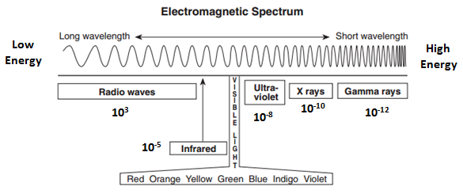

75. This color visible light has the shortest wavelength.

76. This color visible light has the longest wavelength.

77. What two types of energy have wavelengths shorter than 10⁻⁸.

78. Infrared would have wavelength of:

