Name __________________________________________ Date _________ Block __________

**Unit II Review**

**Physical Interactions**

1. **Motion, Velocity and Acceleration**
2. Define:
3. Motion –
4. Reference Point –
5. Speed –
6. Velocity
7. Acceleration –
8. What type of speed would an object have if its:
   1. speed **does not change** over a period of time:
   2. speed **does change** over a period of time:
9. The formula for **speed** =
   1. To solve for **distance** it would be:
   2. To solve for **time** it would be:
10. When an object’s speed or direction changes:
    1. Two examples of this are:
11. When an object slows down it is said to have:
12. 10 m/s, South would represent an object’s:
13. 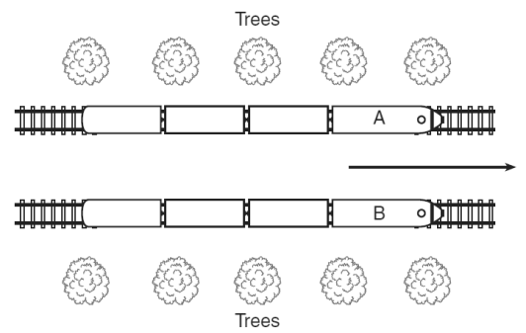 If passengers in Train A were to look at passengers in Train B they would feel as though their train wasn’t moving, why?
    1. What could they use to show them that they were moving?
       1. What is this called?
14. A truck travels 50 km in 2 hr. What is the car’s speed:
    1. Formula:
    2. Work:
    3. Answer:
15. Paul took 30 min to run from his house to his uncle’s house a distance of 5 km west of his house. What was Paul’s velocity?
    1. Formula:
    2. Work:
    3. Answer:
16. 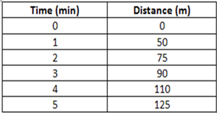What is the average speed between:
    1. 0 and 2 min?
    2. 2 and 4 min?
17. What **type of speed** is shown from:
    1. 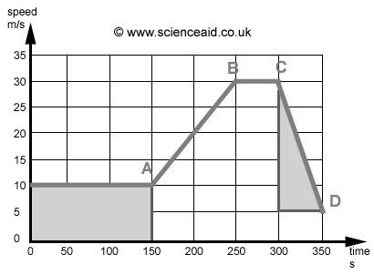0-150 sec:
    2. 150-250 sec:
18. What is **happening to the speed** from:
    1. A to B:
    2. C to D:
19. What is the **acceleration** from:
    1. 150-200 sec:
    2. 300-350 sec:
20. Which diagram shows the block of wood with the greatest acceleration?

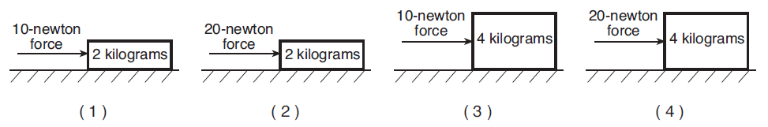

1. What are two ways you could increase acceleration:
2. An object would continue to move at constant speed forever without:
3. **Energy & Forces**
4. Define:
   1. Potential Energy -
   2. Kinetic Energy -
   3. Force –
   4. Newton –
   5. Gravity –
5. Potential energy is associated with:
6. Kinetic energy is associated with:
7. Which force will always be greater kinetic or potential?
8. Forces are described by what two factors:
9. Forces acting on each other in **opposite directions** are:
10. Forces that cause an object to **start moving, slow down or change directions**:
11. The product of friction is:
12. What type of friction is happening when:
    1. Two objects roll over one another:
    2. Two objects slide past one another:
    3. An object moves through a fluid:
13. When a net force is equal to 0 N what type of force do you have?
14. 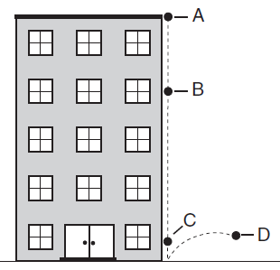According to the diagram on the right:
    1. At which location would the ball have

the greatest potential energy?

* 1. At which location would the ball have

the greatest kinetic energy?

* 1. What factor is affecting the ball as

it drops?

* 1. Why will the bounce at D not be as

high as its starting point at A?

1. 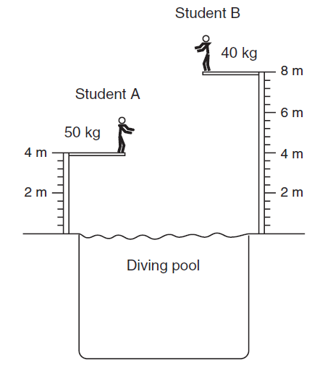According to the diagram to the right:
   1. Which student would have the

greatest kinetic energy?

* + 1. Why?
  1. Which factor will have the greatest

affect on the student’s kinetic

energy, their mass or their velocity?

1. Why?
2. 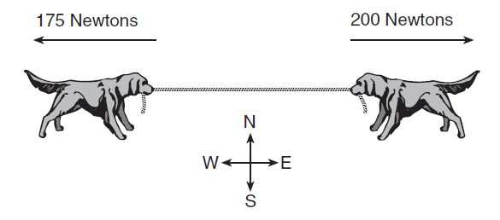In the diagram to the right:
   1. In which direction will the net force point?
   2. What type of force is this an example of?
   3. What will the net force be?

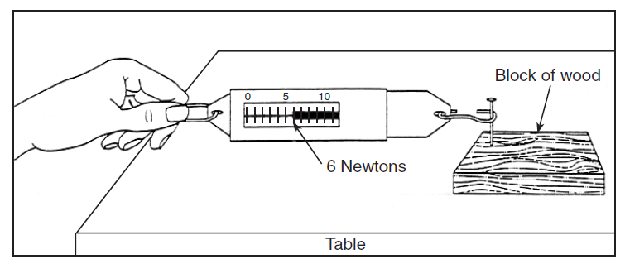

1. In the diagram to the right:
   1. How much force was

needed to pull the block?

* 1. What is the name of the

force acting against the

block of wood?

1. In the diagrams below a person is moving a 50kg object up a ramp. In which diagram is there the **least** amount of friction acting on the object?

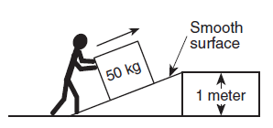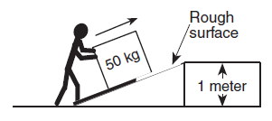

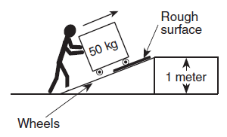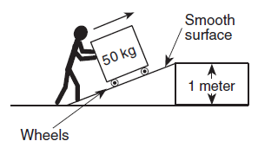

1. **Laws of Motion**
2. Define:
   1. Inertia:
   2. Weight:
3. A Newton is equal to:
4. Law of Inertia is also called:
5. The greater an object’s mass the greater its:
6. Gravitational force only affects an object’s _________________ never its ________
7. What forces work against the laws of motion:
8. What law of motion does each of the following examples best represent: (**1st, 2nd, 3rd**)
   1. A frog leaping upward off his lily pad is pulled down by gravity and lands on another lily pad instead of continuing on in a straight line:
   2. A 4kg ball pushes an object farther than a 1 kg ball when rolled down a ramp:
   3. As the fuel in a rocket ignites, the force of the gas expansion and explosion pushed out the back of the rocket and pushes the rocket forward:
   4. A pitched baseball goes faster than one that is gently thrown:
   5. When you paddle a canoe, the canoe goes forward:
   6. When the air in a balloon is released the balloon will move away from you:
   7. After you start up your motorcycle, as you give it more gas, it goes faster:
   8. When you are standing up on a bus and it suddenly stops, your body continues to move forward:
   9. A penny sitting on top of an index card will fall straight down when the index card is flicked out from under it:
9. **Work & Machines**
10. Define:
    1. Work
    2. Joule
    3. Machine
    4. Input Force
    5. Output Force
11. For work to be done force and motion must be:
12. Machines make work:
    1. How?
13. How does a longer and thinner wedge affect work?
14. How does thread distance on a screw affect work?
15. How does work output compare to work input?
16. What are the characteristics of an ideal machine:
17. A fixed point around which a lever pivots:
18. A machine made from two or more simple machines:
19. The percentage of the input work that is converted to output work:
20. 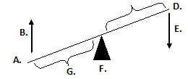Label the diagram:  **C.**
21. As load increases the length of the resistance arm ___________________ while the length of the effort arm __________________________.
22. A force of 1000N was required to push a car 10 m. How much work was done pushing the car?
    1. Formula:
    2. Work:
    3. Answer:
23. Complete the chart:

**ME = Work Output/ Work Input X 100**

**MA = Output Force/Input Force**

|  |  |  |  |  |  |  |
| --- | --- | --- | --- | --- | --- | --- |
| **Student** | **Input**  **Force**  **(N)** | **Output Force**  **(N)** | **Work**  **Input**  **(J)** | **Work Output**  **(J)** | **Mechanical Advantage** | **Mechanical Efficiency** |
| **Sue** | **6** | **12** | **10** | **5** |  |  |
| **Peter** | **5** | **20** | **8** | **6** |  |  |
| **Hank** | **10** | **40** | **10** | **9** |  |  |

1. What type of simple machine do each of the represent:

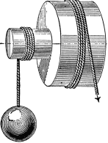



1. 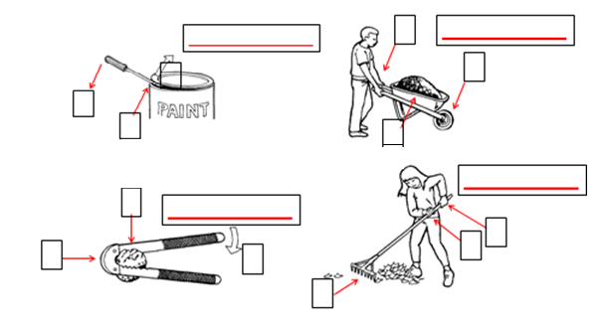 Use the examples below to label the Effort (E), Resistance (R), and Fulcrum (F) for each diagram and then identify the class lever each represents.

