Name ________________________________________ Date _________ Block _________
Understanding the Scientific Method
Readings

- Steps of the Scientific Method

Sharks

Brad and Carol were Marine Scientists with a problem. They wanted to discover which color sharks would attack. Brad believed that sharks would attack dark colors, like black, but Carol believed that sharks would attack bright colors, like yellow.
To test this Brad and Carol wrapped a float with a black life jacket, placed it in the water and observed the behavior of the sharks. After two hours the float was taken out of the water undisturbed. They then placed a yellow jacket around another float, placed it in the water and observed the behavior of the sharks again. After two hours this float was attacked four times.
Brad felt that this problem needed to be studied more. He then took two life sized dummies and put a yellow life jacket on one and a black life jacket on the other and put both into the water. Two hours went by and the sharks did not attack the dummy wearing the black jacket, but they did attack the dummy wearing the yellow jacket, six times. “Well,” Carol said, “sharks do attack brighter colored objects.”

Put the letter of the correct answer in the space provided.

A. Problem B. Hypothesis C. Materials
D. Procedure/Experiment E. Data Collecting F. Conclusion

_____ 1. Brad believes that sharks will attack dark colored objects and Carol
believes that sharks will attack bright colored objects.
_____ 2. Sharks, water, two floats, two life-sized dummies, a yellow life jacket, a
black life jacket, a watch.
_____ 3. Which color do sharks attack?

_____ 4. Sharks attack bright colored objects.

_____ 5. The sharks did not attack the black float nor did they attack the black
dummy. The sharks attacked the yellow float and the yellow dummy.
_____ 6. Observe the attacks made on each float after two hours. Observe the
attacks made on each dummy for two hours.

Baseball

David and Eric wanted to find out which type of baseball bat would hit a baseball farther. David thought that a metal bat would hit a ball further, while Eric thought that a wooden bat would hit a ball further. They went to baseball practice to ask their coach how they could determine who was right.
The coach had each boy hit 50 balls with a metal bat and 50 balls with a wooden bat every day during practice for one week. Each day, both boys hit the ball farther when using the metal bat. “Ah Ha!” said David. “A metal bat does hit a baseball farther.”

Identify the steps of the scientific method used in the passage above.

- What is the problem in this story? ____________________________________________
________________________________________________________________________

- What were the hypothesis statements? _______________________________________
________________________________________________________________________

- Explain the experiment that took place. _______________________________________
________________________________________________________________________
________________________________________________________________________

- What was the conclusion? __________________________________________________
________________________________________________________________________

- Controls and Variables

The best experiments are really just pairs of tests conducted at the same time. One test is called the control, an experiment where all conditions are normal or not changed. The other test, the variable, is like the control experiment with a factor that is changed. There are two types of variables; independent variables and dependent variables. An Independent variable is the factor being changed in an experiment. The Dependent Variable is what happens or takes place because of the changed factor. A “good” experiment has ONLY 1 changed variable. Scientists us the control experiment to compare the outcome of the variable to.

Suppose you want to answer the following question:

Does a certain kind of plant food really help plants grow?

First you would want to make a hypothesis and then test it. You could say “I think that the plant food will help the plants grow.” To test this you would take four identical plants, make sure that they receive the same amount of light and are at the same temperature. Put the plant food in the soil of two plants, group A, and do not add plant food to the soil of the other two plants, group B. Water group A every day and water group B every third day. After two weeks you notice that group A, watered every day and with the addition of plant food, is doing much better than group B, watered every third day and with no plant food added.

Questions and Analysis:

- List the conditions that were the same (identical), controls, for both groups.
  - ______________________________________
  - ______________________________________
  - ______________________________________

- List the conditions that were different, variables, for both groups.
  - ______________________________________
  - ______________________________________

- Can you be sure that the plant food was responsible for helping the plants in group A grow? Why? ______________________________________________________________________
___________________________________________________________________________

- How many variables are there in this experiment? Is it a “good” experiment? Why?______________________________________________________________________
___________________________________________________________________________

- What change could you make in this experiment to make sure that the plant food was responsible for helping the plants in group A grow? _________________________________
___________________________________________________________________________

Earthworms

A teacher wanted to see if earthworms were sensitive to light. She decided to go to the library to do some research on earthworms prior to conducting her experiment. Based on what she learned she formed her hypothesis statement, “I think that earthworms are sensitive to light and will therefore move away from the light.” The teacher proceeded to use two groups of 5 earthworms, of the same kind, for her experiment. She also made sure to keep the temperature and humidity constant for the two groups. The only difference between them was that one group was exposed to light and the other group was kept in complete darkness. The teacher measured their reactions in terms of cm/min and recorded this data on a data table. In the end the teacher concluded that earthworms are sensitive to light because only the earthworms in the light moved and they moved away from the light. She accepted her hypothesis.

Identify the steps of the scientific method used in the passage above.

- Write a problem statement for this experiment? _______________________________
_______________________________________________________________________

- What were the controls?
  - __________________________________________________________
  - __________________________________________________________
  - __________________________________________________________

- What was the independent variable (the factor changed)? _______________________
________________________________________________________________________

- What was the dependent variable (What happened because of the factor that was changed)? _______________________________________________________________

- What was the teacher’s conclusion? _________________________________________
_______________________________________________________________________

- Observations and Inferences

Factual information collected using one of your five senses is an observation. You can see something, taste something, smell something, touch something or hear something. Regardless of which way you collect this information it actually occurred. The educated guess that can be based on your observation is the inference. This is not factual and may not even be close to the actual reason something happened.

- Identify each of the following statements as either an observation (O) or inference (I). If the statement is an observation identify which sense was used to collect this information.

_____ 1. Peter is wearing a sweatshirt.

_____ 2. A skunk was just hit by a car because I can smell it.

_____ 3. Jenny just finished cooking because the stove is hot.

_____ 4. The music is loud.

_____ 5. The lemonade is sweet.

_____ 6. Kyle must be working out because the music is playing very loudly.

_____ 7. A skunk just sprayed.

_____ 8. Peter is cold because he’s wearing a sweatshirt.

_____ 9. The stove is hot.

_____ 10. Anne doesn’t know how to make lemonade because it’s way too sweet.

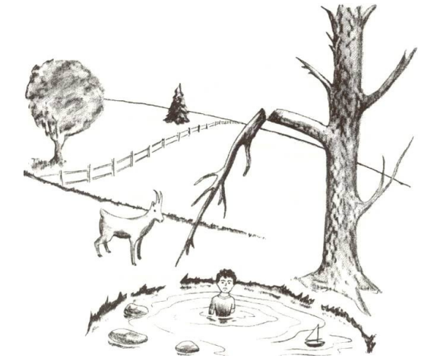
- Use the picture to the right to make 3 observations and 3 inferences.

Observations:

Inferences:

