Name ____________________________________________ Date __________ Block ________

Understanding Data Tables
and Graphs

- Data Tables

A student was investigating the effect of surface area on the evaporation of water. She hypothesized that if pans with different surface area were set out, then those with larger surface areas would evaporate more water, because evaporation increases with the amount of surface area exposed to the air. She did five trials and found the following results.

Pan A had a diameter of 10 cm² and evaporated 2 ml of water
Pan B had a diameter of 50 cm² and evaporated 10 ml of water
Pan C had a diameter of 20 cm² and evaporated 4 ml of water
Pan D had a diameter of 40 cm² and evaporated 8 ml of water
Pan E had a diameter of 70 cm² and evaporated 14 ml of water

Construct a data table to better display these results and also provide better meaning.

Data Table:

Pan | Diameter  (cm²) | Evaporation  (mL)
 | 10
C |  | 4
B

Analysis:
_____ 1. How much water could we predict a pan with a diameter of 90 cm² would
evaporate out?
- 20 mL b. 15 mL c. 10 mL d. 18 mL

2. What connection can you make between the diameter of the pan and the rate of
evaporation? __________________________________________________________
_____________________________________________________________________
_____________________________________________________________________

- Graphs

_____ 3. If solids have closely packed particles, liquids have loosely packed particles
and gases have particles the farthest spread apart, which bar graph best
represents this information?
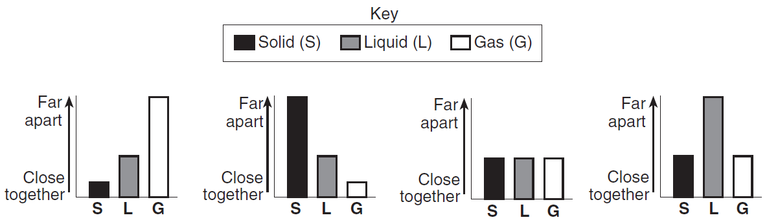

B.
A.
D.
C.

_____ 4. Which graph shows that more grams of a substance can be dissolved in water
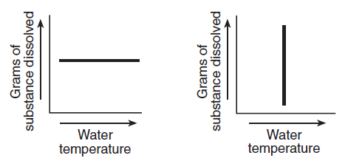
as the water temperature increases?
D.
C.
A.
B.
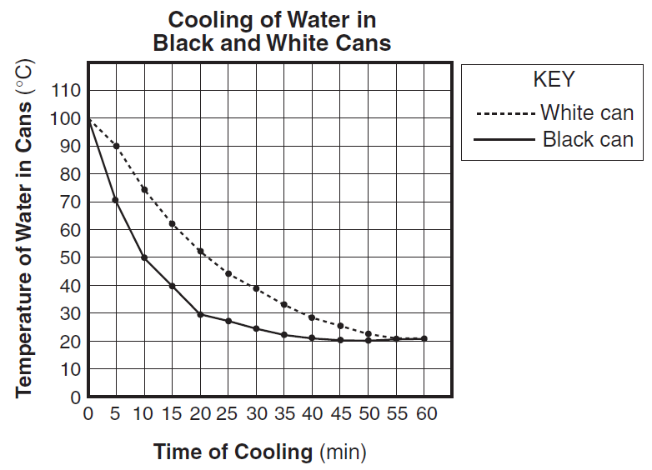
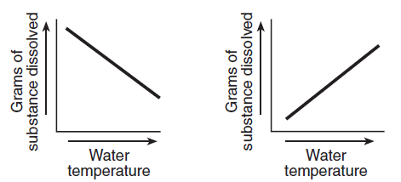
The graph below shows the results of an experiment comparing the cooling rates of two cans of identical size and shape that are painted different colors and filled with water at 100°C. The cans were allowed to cool for 60 min. The temperature of the water in each can was recorded every 5 min.

5. Which color can had the slowest
cooling rate in the first 10 min of the
experiment?

6. At 20 min, what was the temperature
of the water in the black can?

7. At the end of the 60 min, what did
you notice happened to the water in
both colored cans.

- Making Connections

A student made an entry in her laboratory notebook:

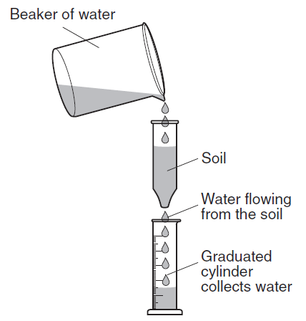
We are doing an experiment to determine if the size of soil particles affects the amount of water that flows through soil. We poured 100 mL of water through four different types of soil. The equipment and results are shown below.

Results:
Gray soil: average particle size was 2.0 mm and 80mL of water flowed through. Tan soil: average particle size was .5mm and 40 ml of water flowed through. Brown soil: 60 mL of water flowed through an average particle size of 1.5 mm and Black soil: average particle size of 1.0 mm and 50 mL of water flowed through.

Data Table:
Organize the results above into the data table to show the average particle size and the amount of water that flowed through for each type of soil. Make sure to include column headings, data, and units in the table.

 | (mL) | Particle Size  ( )

Graph:
Construct a bar graph for the data in the data table.
Water Flow Through Different Soil Sizes

100

80
Water Flow (____ )

60

40

20

_______________________ (mm)
0
2.0
1.5
1.0
.5
Analysis:

8. Which particle size allowed 50 mL of water to flow through? ____________________

9. 80 mL of water was able to flow through which particle size? ___________________

10. Which color soil allowed the least amount of water to flow through? ____________

11. What conclusion can you make about the size of the particles and the amount of
water that flowed through it? ____________________________________________
____________________________________________________________________
____________________________________________________________________

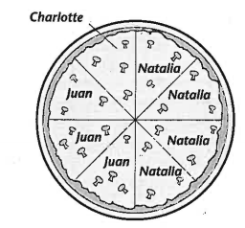
Natalia, Juan and Charlotte went to a pizza parlor and ordered a pizza. Below is a circle graph that represents how many slices each person ate. Use this information to complete the data table and answer the questions below.

Name |  | Percent
 |  | 12.5%

Analysis:

- Who ate the most slices of pizza, how many? ________________________________

- What percentage more did Juan eat than Charlotte? __________________________

- How much of the pizza did both Juan and Charlotte eat together? _______________

