Name ____________________________________________ Date ________ Block _________

Making a Topographic Map
Lab

Topographic maps are birds-eye views of an area that are used to show the elevation, topography and gradient of Earth’s surface. Topographic maps use contour lines that connect points of equal elevation; they never intersect and always close to form an irregular circle. The elevation separating two contour lines is called the contour interval. A gradient is the difference in elevation divided by the distance between two points (gradient = rise/run). As a gradient becomes steeper the contour lines get closer together. As a gradient becomes more gradual, the contour lines are spaced further apart.

Procedure:
- Use the marked side of the plastic box to fill the plastic box to the 1 cm line with the colored water.
  - Put the top on the box and draw a contour line that matches the water line.
- Remove the lid and fill the plastic box to the 2 cm line.
  - Put the top back on and draw the contour line that matches the new water level.
- Continue to fill the plastic box up to the 7cm line.
  - Remember to draw the contour lines after each 1 cm line is filled.
- Transfer your contour lines from the plastic box top to the space provided in this lab.
  - Label the 1 cm line as 6,280 ft, 2 cm = 6530 ft, 3 cm = 6780 ft, 4 cm = 7030 ft, 5 cm = 7280 ft, 6 cm = 7530 ft, 7 cm = 7780 ft and 8 cm = 8030 ft

Analysis:

- What view is a topographic map drawn from? __________________________________

- What is a topographic map used to show? _____________________________________
________________________________________________________________________

- What are contour lines? ____________________________________________________
________________________________________________________________________

- Define: gradient - _________________________________________________________
________________________________________________________________________

  - What is the formula for gradient? ______________________________________

- As contour lines get closer together, what does this indicate? _____________________

- As contour lines get further apart, what does this indicate? _______________________

Topographic Map

Analysis:
- On your map locate:
  - The most gradual gradient and place the letter A at the highest elevation and letter B at the lowest elevation, connect the two points with a straight line.

    - Determine the gradient of this line: (gradient = rise/run)
      - Work:

      - Answer:

  - The steepest gradient and place the letter C at the highest elevation and the letter D at the lowest elevation, connect the two points with a straight line.
    - Determine the gradient of this line: (gradient = rise/run)
      - Work:

      - Answer:

Making Connections – Use the diagrams below to answer the questions that follow.
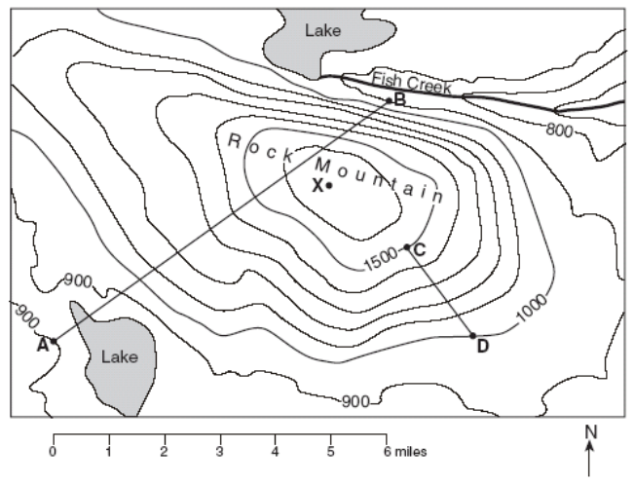

- What is the elevation at:

A: __________ B: __________ C: __________ D: __________

- What is the contour interval of this map? _________________
- What is the gradient between points C and D?
Formula:

Work:

Answer:

_____ 4. Which profile would best represent the image above between points A and B?
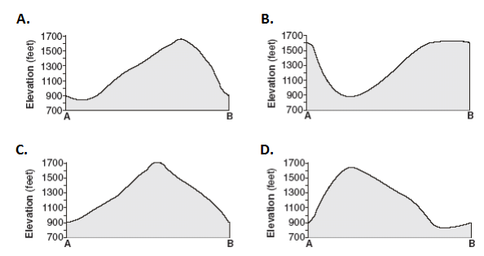

Topographic Profile – complete a topographic profile for the map below.
