**[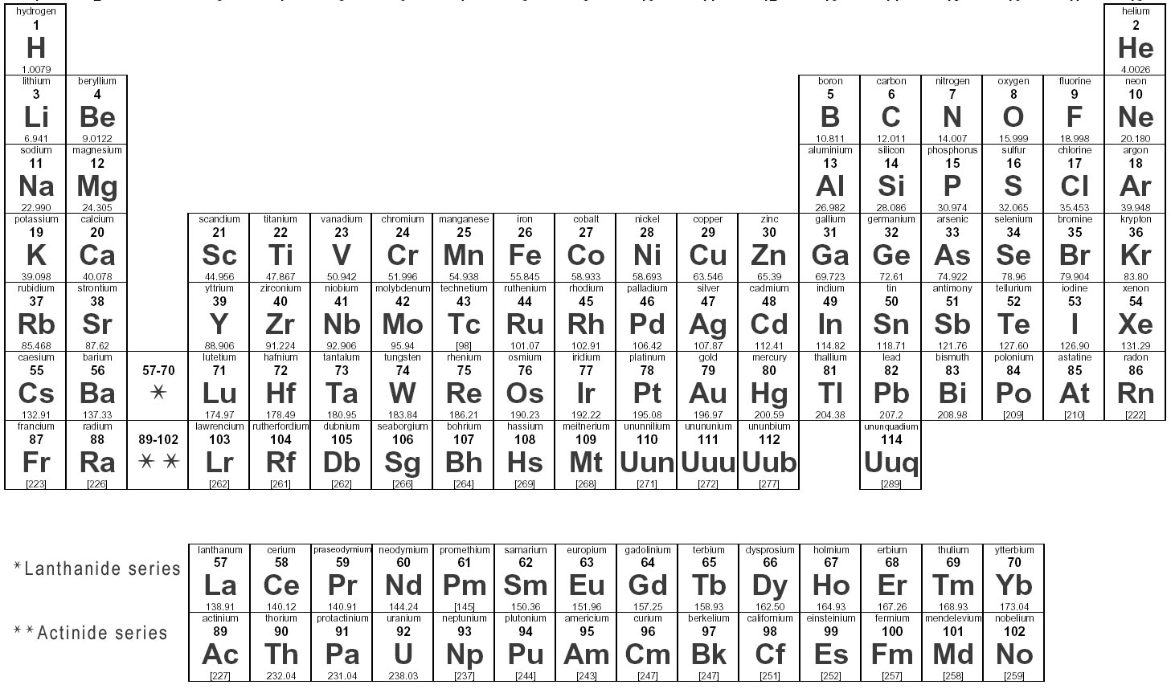](http://images.search.yahoo.com/r/_ylt=A0PDoX_ut9hP_04AtR.jzbkF;_ylu=X3oDMTBpcGszamw0BHNlYwNmcC1pbWcEc2xrA2ltZw--/SIG=12s04qofg/EXP=1339631726/**http:/excelmodeljetsclub.blogspot.com/p/periodic-table-of-elements.html)The Periodic Table**

**Key**:

* **Metal**
* **Metalloid**
* **Nonmetal**
* **Nobel Gas**