Name ____________________________________ Date ____________ Block ______________

Stratigraphy Project

Stratigraphy is the branch of geology that studies rock layers and layering. Nicholas Steno, “The Father of Stratigraphy” suggested that geology is not totally chaotic but instead preserves a chronological record of Earth’s history and past life in its layers. With Steno’s contributions we now have the following laws of stratigraphy:
- Law of Superposition – In undisturbed rock layers, the oldest layer lies at the bottom and the youngest layer at the top.
- Law of Cross-Cutting – An igneous intrusion (lava) that cuts through existing rock is always younger than that disturbed rock.
- Law of Unconformity – A surface that has a significant gap, layers missing, from its rock record due to erosion or non-deposition. ( )
  - Disconformity – An eroded surface between sedimentary layers that are parallel to each other.
  - Angular Unconformity – Younger strata overlie an erosional surface on tilted or folded rock layers.
  - Nonconformity – When igneous rocks are eroded and covered by younger sedimentary or volcanic rock.

Procedure:
- Draw and create as many cross-sections as needed to determine your final project grade (Maximum = 260 pts)
- Identify each diagram.
- Create a key (10 pts) to identify each rock type.
  - Each rock type should also have its own color.
- Use a ruler to measure each layer accurately.
- Label and identify each of the parts of the diagram correct:
  - Oldest layer/youngest layer
  - Disconformity/Nonconformity/Unconformity
  - Angular Unconformity
  - Foot Wall/Hanging Wall
  - Fault Plane
  - Igneous Intrusion
  - Rock Layer Depths

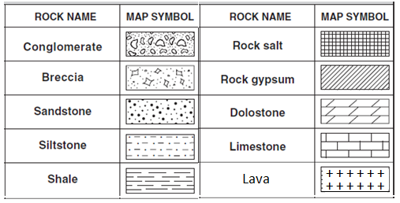
Rock Types:

Cross-Sections

- Simple Cross-Section (10 pts)
Bottom 2 cm of sandstone
4 cm of dolostone
6 cm of limestone
2 cm of conglomerate
5 cm of silt stone
top 3 cm of shale

- Simple Cross-Section (20 pts)

Bottom 6 cm of dolostone
4 cm of limestone
An igneous intrusion
2 cm of conglomerate
4 cm of shale
An igneous intrusion
6 cm of sandstone
An igneous intrusion
4 cm of Breccia
top 2 cm of silt stone

- Normal Fault (25 pts)

- The Foot Wall
Bottom 2 cm of silt stone
4 cm of conglomerate
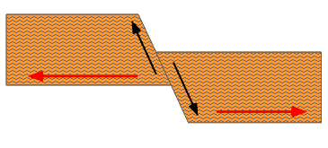
4 cm of limestone
2 cm of shale
Top 4 cm of dolostone

- The Hanging Wall
Bottom 4 cm of limestone
2 cm of shale
Top 4 cm of dolostone

- A Graben (35 pts)

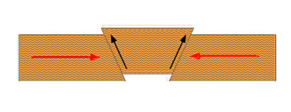
- Each Foot Wall
Bottom 2 cm of sandstone
4 cm of conglomerate
6 cm of dolostone
Top 2 cm of limestone

- The Hanging Wall
Bottom 1 cm of conglomerate
6 cm of dolostone
Top 2 cm of limestone

- Angular Unconformity followed by a Simple Cross-Section (30 pts)

- Angular Unconformity – 16 cm in width
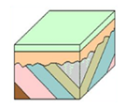
Bottom 4 cm shale
4 cm rock salt
4 cm conglomerate
Top 4 cm rock gypsum

- Simple Cross-Section
Bottom 2 cm of conglomerate
Top 4 cm of dolostone

- Reverse Fault (25 pts)

- The Hanging Wall
Bottom 3 cm of shale
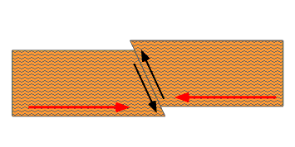
3 cm of conglomerate
3 cm of sandstone
3 cm of rock salt
Top 3 cm of dolostone

- The Foot Wall
Bottom 3 cm of conglomerate
A Disconformity
3 cm of rock salt
Top 3 cm of dolostone

- Angular Unconformity – Simple Cross-Section (50 pts)
- Angular Unconformity – 21 cm in width
Bottom 3 cm of shale
3 cm of rock gypsum
3 cm of limestone
3 cm of sandstone
3 cm of breccia
3 cm of shale
Top 3 cm of sandstone

- Simple Cross-Section
Bottom An igneous intrusion
4 cm of limestone
6 cm of shale
2 cm of breccia
4 cm of sandstone
An igneous intrusion
2 cm of conglomerate
2 cm of sandstone
Top 2 cm of limestone

- Simple Cross-Section (15 pts)
Bottom 4 cm of limestone
6 cm of sandstone
2 cm of conglomerate
A disconformity
4 cm of limestone
2 cm of shale
Top 2 cm of breccia

- Simple Cross-Section (40 pts)
Bottom 2 cm of nonconformity – igneous
2 cm of sandstone
2 cm of conglomerate
2 cm of sandstone
2 cm of limestone
A 10 cm wide angular unconformity (2 cm wide each) of:
      - Conglomerate (oldest), sandstone, breccia,
shale, and limestone (youngest)
4 cm of rock gypsum
2 cm of shale
2 cm of dolostone
2 cm of limestone
Top An igneous intrusion

