Name ___________________________________________ Date _________ Block __________

Unit VI
Rocks & Minerals and
Astronomy
Review Sheet

A. Weathering & Erosion

A layer of soil that differs in color and texture from the layers above or below it.

Dark colored organic material in soil.

The chemical and physical processes that break down rock at Earth’s surface.

The loose layer of dead plant leaves and stems on the surface of the soil.

The process by which water, ice, wind or gravity moves weathered rock and soil.

The type of weathering that changes both the size and shape of the rock but not
its composition:

Water, oxygen, carbon dioxide and acid rain are all examples of:

Weathering is the result of the interactions between the lithosphere with:

- Making Connections – Use the diagrams to answer the questions that follow.

What type of weathering do each of the pictures best represent?

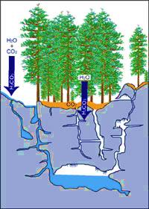
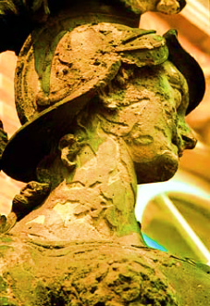
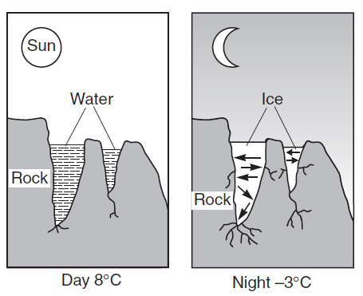

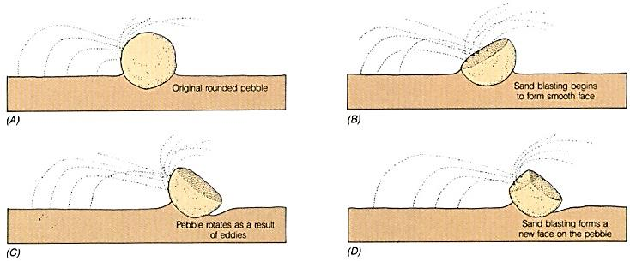

B. Minerals & Rocks

The look and feel of a rock.

Rock formed from the cooling of lava at Earth’s surface.

The tendency of a mineral to break along regular surfaces in one or more directions.

How a mineral reflects light from its surface; metallic or non-metallic.

Rock formed from the cooling of magma inside Earth’s crust.

What three characteristics must all minerals have:

The driving force of the rock cycle:

What will the crystal formation be if:
- If magma cools slowly:
- If lava cools rapidly:

Metamorphic means:

“Fire” means:

- Understanding Diagrams – Use the diagrams to answer the questions that follow.
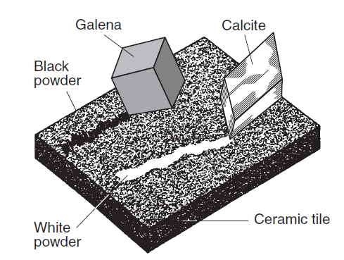
What property test is this diagram best demonstrating?

If the ceramic tile has a hardness of 6.5 – 7, and
neither mineral can scratch it, what would be a
good estimate of their harnesses’?

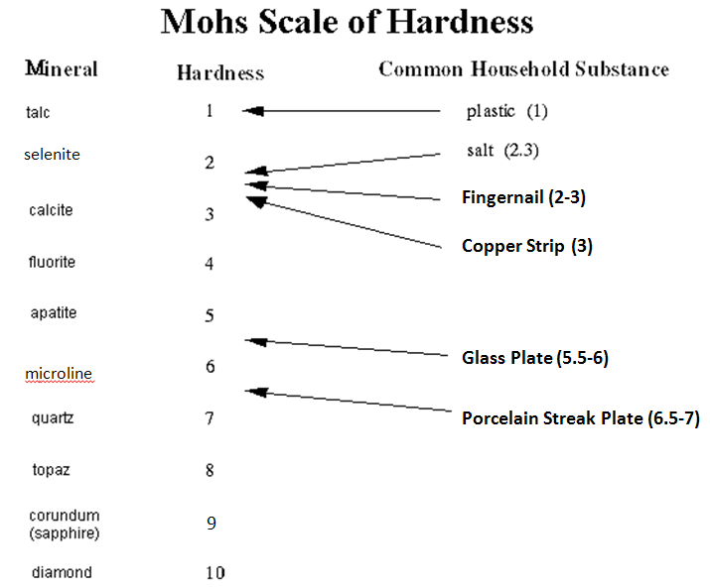

A mineral that cannot be scratched by plastic but can be by salt would be:

Fluorite has a hardness of:

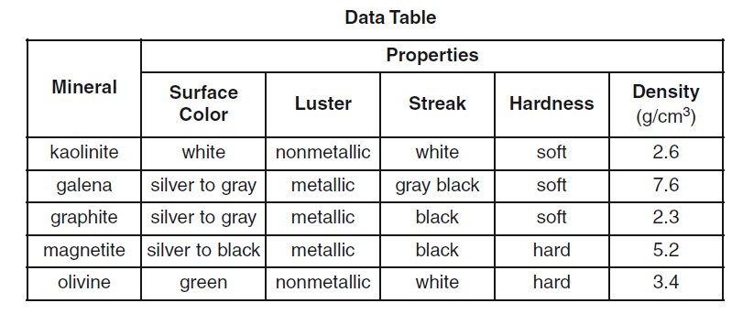

This mineral is soft, has a black streak and has a silver to gray surface color:

What property separates galena from graphite?

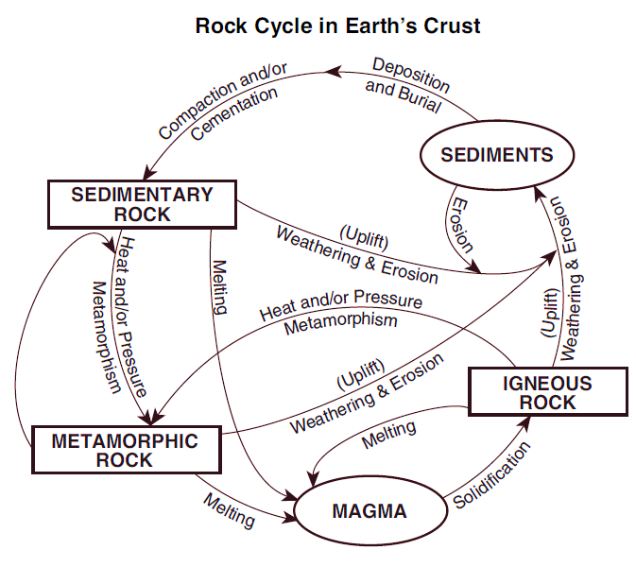

Identify two processes that must occur in order to change any rock into a Metamorphic
Rock:

For any rock to become sedimentary rock it must go through these two processes:

Melting and Solidification produces:

- Stratigraphy
- Matching – Put the letter of the correct answer in the space provided.

The block of rock layers positioned over the fault plane.

Rock layers

The branch of geology that studies rock layers and layering.

The block of rock layers positioned under the fault plane.

A break or fracture in rock layers due to friction.

This law states: The oldest layer of rock lies at the bottom and the youngest layer at the top.

This law states: A surface that has a significant gap, layers missing, from its rock record due to erosion or non-deposition.

This law states: An igneous intrusion that cuts through existing rock is always younger than the rock it cuts through:

- Making Connections – Use the diagrams provided to answer the questions that follow.

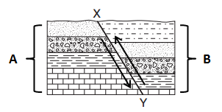
What type of fault does the diagram to the right best represent?

Which letter best represent the hanging wall?

Which letter best represents the foot wall?

Which letters best represent the fault plane?

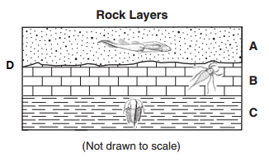
Which layer represents the youngest layer?

Which layer represents the oldest layer?

Letter D represents a:

- Earth in Space

The partial or total blocking of one object by another.

The path of an object as it revolves around another object in space.

Any object that revolves around another object in space.

When neither hemisphere is tilted toward or away from the sun (equal day, equal night).

When the noon sun is directly overhead at either 23.5° N or S latitude.

One complete rotation of Earth takes

One complete revolution of Earth takes

Seasons on Earth occur due to:

What two seasons are solstices:

What two seasons are equinoxes:

The object both rotates and revolves in 27.3 days.

Tides are caused by:

The movement of an object around another object.

When the lit surface of the moon, facing Earth, is decreasing.

Tides with the least difference between high and low; occur on 1st and 3rd quarter moon phases.

When the lit surface of the moon, facing Earth, is increasing.

Higher than normal high tides that occur on full and new moon phases.

- Understanding Diagrams – Use the diagrams below to answer the questions that follow.
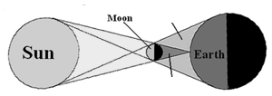
A.
Penumbra

Umbra
B.
What type of eclipse does this
Best represent?

- Moon Phases

Which letter would represent a full moon, as seen from Earth?
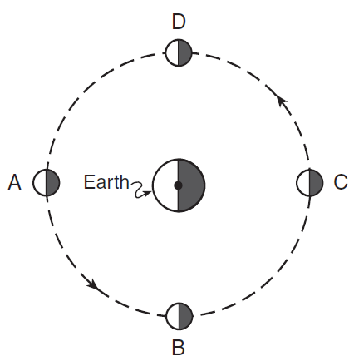
Which letter best represents a new moon?

Which letter best represents a first quarter?

Which letter best represents a third quarter?

- Seasons in the Northern Hemisphere
A.
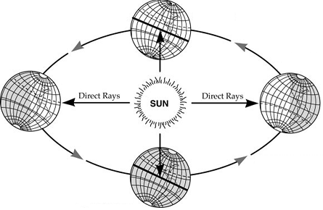
D.
B.
C.
A.
What season would be taking place at:
- letter B:
- Letter D:
- Letter A:
- Letter C:

What movement does this diagram best represent?

- Understanding Diagrams – Use the diagrams to answer the questions that follow.
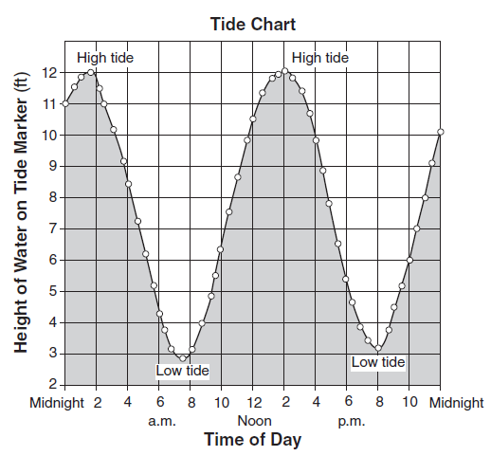

What type of tide was taking place at 2pm?

What was the height of the water level at 8pm?

What is the time difference between a high
and low tide?

- The Solar System

The correct order of the 8 planets, closest to the sun outward, are:

Fixed points in space that shine due to the burning of its own gases:

The two forces that keep planets in their orbits:

These objects consist mostly of Hydrogen and Helium:

The “Red planet”

Has the “Great Red Spot”

Tilted at 90°

Called “Earth’s twin”

Has 1000 rings

- Understanding Diagrams – Use the diagrams to answer the questions that follow.

Planet | Diameter | Rotations  (Earth Days) | Distance from Sun  (km) | Revolution (Earth years) | Moons
Jupiter | 142,800 | .41 | 778,000,000 | 12 | 18
Mars | 6794 | 1.03 | 228,000,000 | 1.9 | 2
Uranus | 51,200 | .72 | 2,871,000,000 | 84 | 20
Venus | 12,104 | 243 | 108,000,000 | .62 | 0
Saturn | 120,540 | .43 | 1,427,000,000 | 29 | 18
Earth | 12,756 | 1 | 150,000,000 | 1 | 1
Neptune | 49,500 | .67 | 4,497,000,000 | 165 | 8
Mercury | 4878 | 59 | 58,000,000 | .24 | 0

The largest planet is:

The planet that has the most similar rate of rotation to Earth is:

The planet that has the shortest orbit is:

This planet has two satellites:

The distance from the Sun to Mars is approximately four times the distance between
the Sun and what other planet?
Show your Work:

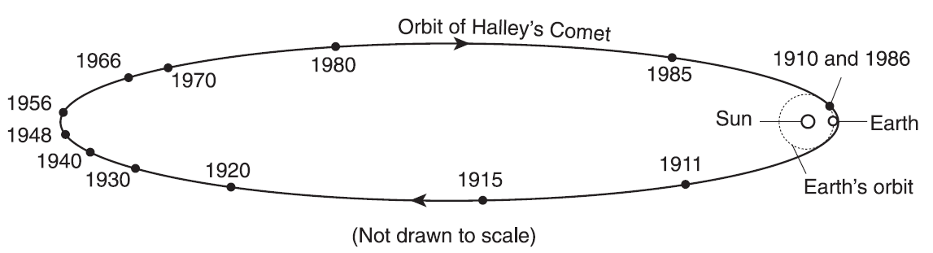

Name one date that Halley’s Comet was visible from Earth?

How long does one orbit of Halley’s Comet’s take?

How many more years are left before we see Halley’s Comet again from Earth?
  - How can you figure this out?

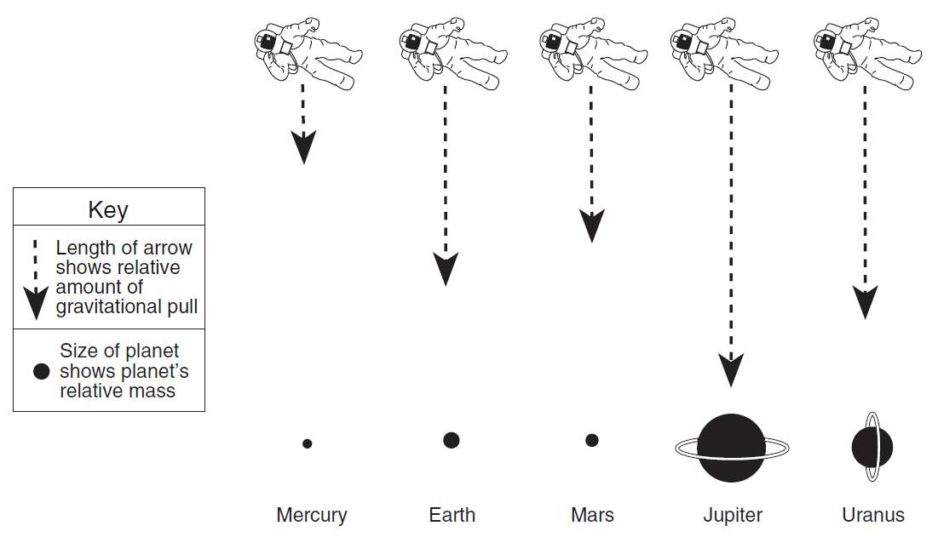

Name two planets that have a greater gravitational pull than Earth:

How does Mercury’s mass affect its gravitation pull?

- The Universe

Stars are classified by their:

Hot stars are this color:

How long a star lives for depends on its:

The Milky Way is an example of a:

Our sun’s size is considered to be:

A star’s color corresponds to its:

A star’s size and temperature determines its:

90% of all stars are classified as:

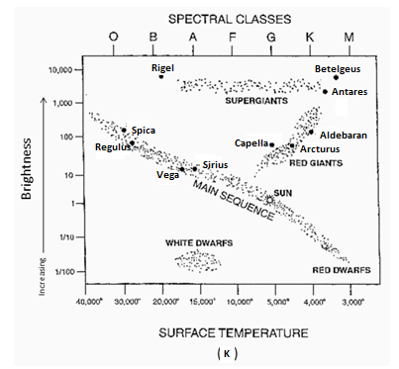
- Understanding Diagrams – Use the diagrams below to answer the questions that follow.

What type of star is our sun classified as:

Capella has a spectral class of:

What is the brightness and surface temperature
of Rigel?

These starts have a temperature around 15,000K,
A brightness between 1/10 – 1/100 and a
spectral class of B – F:

Have a GREAT Summer and
please come visit When you’re freshman!

Mrs. Fulton

