Name ____________________________________________ Date _________ Block _________

Punnett Square Practice
Vocabulary:
- Homozygous = same (TT or tt)
- Heterozygous = different (Tt)
- Phenotype = physical appearance (TT, Tt or tt)
- Genotype = gene combinations (Tall or short)

- Monohybrid Crosses

- Homozygous Black fur X Homozygous Black fur

(Black = B, white = b) Genotype:
____% - BB
_____ X _____ Phenotype:
____% - Black fur

- Homozygous Greed pod X Heterozygous Green pod

(Greed = G, yellow = g) Genotype:
____% - GG
_____ X _____ ____% - Gg
Phenotype:
____% - Green pod

- Heterozygous Tall X Heterozygous Tall

(Tall = T, short = t) Genotype:
____% -
_____ X _____ ____% -
____% -
Phenotype:
____% - Tall
____% - short
- A homozygous bushy tailed squirrel is crossed with a homozygous non-bushy tailed squirrel. What are the genotypes and phenotypes of the offspring?

(Bushy tail = B, non-bushy tail = b)

_____ X _____ Genotype:
____% - Phenotype:
____% -

- A rat with red eyes is crossed with a heterozygous rat with black eyes. What are the genotypes and phenotypes of the offspring?

(Black eyes = B, red eyes = b)

_____ X _____ Genotype:
____% -
____% -
Phenotype:
____% -
____% -

- A gray mouse crosses with a white mouse and has 100% gray babies. What are the genotypes of the parents and offspring?
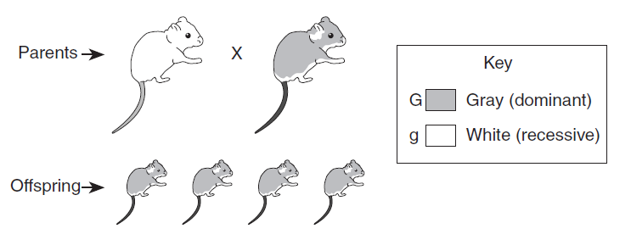
_____ _____

_____ _____ _____ _____
- Incomplete Dominance

- Homozygous Red flower X Homozygous White flower

(Red = R, White = W, Pink = RW)

_____ X _____ Genotype:
____% - RW
Phenotype:
100% -

- Heterozygous Pink flower X Homozygous Red flower

(Red = R, White = W, Pink = RW)

_____ X _____ Genotype:
____% -
____% -
Phenotype:
____% -
____% -

- Heterozygous Pink flower X Heterozygous Pink flower

(Red = R, White = W, Pink = RW)

_____ X _____ Genotype:
____% -
____% -
____% -
Phenotype:
____% -
____% -
____% -

Use the chart, Determination of Blood Types, to answer the following questions.
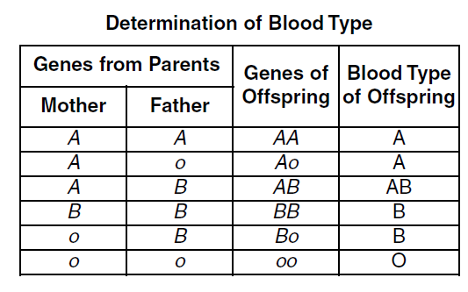

- What genotype combinations will produce an offspring with:
- Blood type A?
- Blood type B?
- Blood type AB?
- Blood type O?

- Which blood type is:
  - Dominant -
  - Recessive -

- A person with blood type AB is crossed with a person with blood type AB. What percentage of the offspring will have the listed blood types?

(A = dominant, B = dominant, o = recessive)

_____ X _____ Blood Type A: ____%

Blood Type AB: ____%

Blood Type B: ____%

Blood Type O: 0%

- A person with blood type Bo is crossed with a person with oo blood type. What percentage of their offspring will have the listed blood types?

(A = dominant, B = dominant, o = recessive)

_____ X _____ Blood Type A: ____%

Blood Type AB: ____%

Blood Type B: ____%

Blood Type O: ____%

- A person with blood type Ao is crossed with a person with Bo blood type. What percentage of their offspring will have the listed blood types?

(A = dominant, B = dominant, o = recessive)

_____ X _____ Blood Type A: ____%

Blood Type AB: ____%

Blood Type B: ____%

Blood Type O: ____%

