Name _________________________________________ Date __________ Block ___________

Potential & Kinetic Energy
Lab

Any change in motion requires energy. Energy can be either potential or kinetic. Potential energy is stored energy. It is associated with the object’s position. When you increase an object’s height you increase the amount of stored energy the object has. Kinetic energy is the energy of motion. Kinetic energy depends on the object’s mass and velocity. When you double the mass of an object, you double the object’s kinetic energy. When you double the object’s velocity, you quadruple the kinetic energy. Kinetic energy can never be greater than potential energy due to forces that act against the object; friction and gravity. Gravity pulls all objects toward Earth at 9.8 m/s². Friction is a force that works in the opposite direction that an object is moving and produces heat as an end product. Air resistance is an example of friction working against a falling object and pushing in the opposite direction of the falling object.

Analysis:

- Matching – Put the letter of the correct answer in the space provided.

_____ 1. Potential Energy A. Energy of motion.

_____ 2. Kinetic Energy B. A force that works in the opposite direction that
an object is moving.
_____ 3. Gravity C. Stored energy.

_____ 4. Friction D. The force that pulls all objects toward Earth (9.8
m/s²)

- Mass

- Find the mass of each ball and record in the data table below.
- Place the 28cm end of the ruler on the edge of the 5.0 cm tall wood block.
- Place the 0cm end of the ruler on the black line, inside the circle, on the mat.
- Roll each ball from the indicated distance, 20 cm, on the metric ruler.
- Measure the distance the cup moved, according to the ruler on the mat.
  - Repeat each roll three times and calculate the average for each roll. (total/3)
    - Record data on the data table provided.

Marble Release  (20 cm) | Cork  (_____ g) | Wood  (_____ g) | Rubber  (_____ g) | Aluminum  (_____ g)
Trial 1
Trial 2
Trial 3
Average

Analysis:
- As the mass of the ball increased, what happened to the distance the cup moved?____________

- If I were to roll a Styrofoam ball down this same setup, how do you think the distance the cup moved would compare to the other balls? Why? _______________________________________
________________________________________________________________________

- Velocity

- Roll each ball from the indicated distance, 10 cm, on the metric ruler.
- Measure the distance the cup moved, according to the ruler on the mat.
  - Repeat each roll three times and calculate the average for each roll. (total/3)
    - Record data on the data table provided.

Marble Release  (10 cm) | Cork | Wood | Rubber | Aluminum
Trial 1
Trial 2
Trial 3
Average

Analysis
- As you decreased the distance the marble rolled, what happened to the distance the cup moved? Why? _________________________________________________________________
_____________________________________________________________________________

- At what release point did the marble have the:
  - Greatest potential energy: _________________________________________________

  - Least potential energy: ____________________________________________________

_____ 3. What rule of kinetic energy does this best demonstrate?
- Double mass, doubles kinetic energy.
- Double velocity, quadruples kinetic energy.
- Double mass, kinetic energy stays the same.
- Double velocity, kinetic energy stays the same.

- Making Connections – Use the diagrams below to answer the questions that follow.
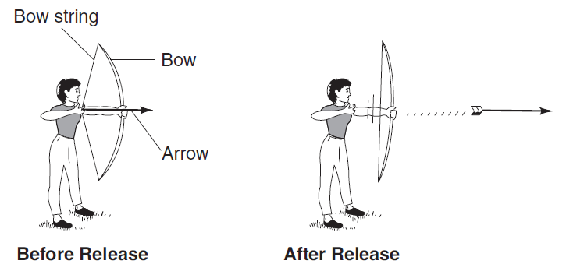

1. What type of energy does the arrow have before release? ________________________
2. What type of energy does the arrow have after release? _________________________
2. State one change that could be made, other than changing the angle the bow is held,
that would allow the arrow to travel a greater distance. Why? _____________________
________________________________________________________________________

- What two factors would affect the path and speed of the arrow after it is released?
  - ___________________________________________________
  - ___________________________________________________
______________________________________________________________________________
_____ 4. The diagram below shows smooth blocks of wood being pushed across the same surface. The mass of the block and the amount of force applied are labeled in each diagram. In which diagram would the block of wood have the greatest acceleration.
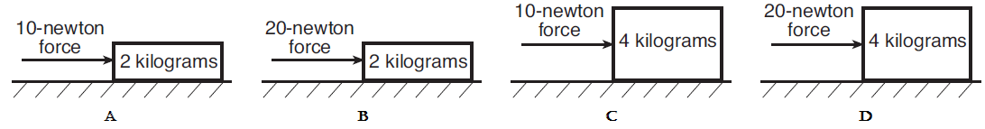

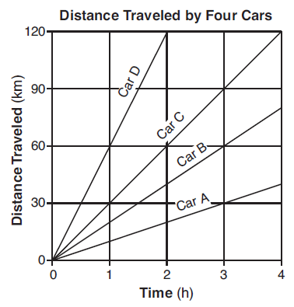
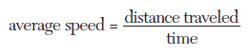

_____ 11. Which car traveled at an average speed of
20 km/hr?
- Car A b. Car B
c. Car C d. Car D

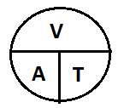
If both students have an acceleration of 9.8 m/s², what would each student’s velocity be, upon hitting the water, if Student B fell for 8 seconds and Student A fell for 4 seconds?

Acceleration = Velocity/Time

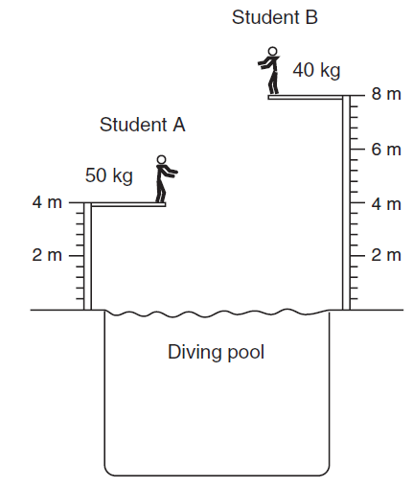
Student A: Student B:
Formula: Formula:
Work: Work:

Answer: Answer:

