Name ____________________________________________ Date _________ Block _________

Penny Weight
Lab

A lever is a simple machine where a bar rotates around a fixed point, fulcrum. The effort force is the force being applied to a machine. The Load, resistance force, is what the effort force is working against. To keep a lever in balance the location of the fulcrum would need to change as the resistance force changes thus changing the length of the effort arm. There are three classes of levers; 1st class – the fulcrum is between the effort and the load, 2nd class – the load is between the fulcrum and the effort and 3rd class – the effort is between the fulcrum and the load.
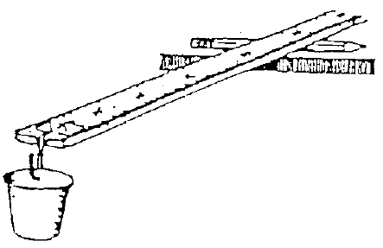
Procedure:
- Balance the meter stick, with the cup attached to the 100 cm end, on a pencil.
  - Record the length of the effort arm on the data table for the 0 penny measurement.
- Add 5 pennies to the cup, rebalance and record the new effort arm length onto the data table.
  - Determine the difference of the effort arm distances by subtracting the prior distance from the new distance (5 penny effort arm distance - 0 penny effort arm distance).
- Continue to add 5 pennies at a time and find the new location of the effort arm. Be sure to record these measurements on your data table.
- Construct a Bar Graph of your results on the graph paper provided.
  - Remember: Title, X axis label, Y axis label, proper spacing, neat!

Data Table:

# of Pennies | Effort Arm Length  (cm) | Difference  (cm)
0 |  | --------
5
10
15
20
25
30
35
40
45
50

Analysis:

- What is a lever? __________________________________________________________
________________________________________________________________________

- Label the diagram of the meter stick with the following labels: Fulcrum, Effort Force, Effort Distance, Resistance Force and Resistance Distance.

Effort Arm

Resistance Arm

- What type of lever does this represent? _______________________________________

  - Why? _____________________________________________________________
__________________________________________________________________

- As you added more pennies to the cup, what happened to:

  - The length of the effort arm? _________________________________________

  - The length of the resistance arm? _____________________________________

  - The location of the fulcrum, as compared to the load? _____________________
_________________________________________________________________

______________________________________________

_________________________________________________

______________________________________________

