Name ___________________________________________ Date _________ Block __________

Isobar and Isotherm Maps

Isobars and isotherms are lines on weather maps which represent patterns of pressure and temperature, respectively. They show how temperature and pressure are changing over space and help describe the large-scale weather patterns across a region on the map.

Isotherms
Isotherms are lines of constant or equal temperature. They are often used on weather maps by meteorologists to give a large scale view of temperatures across the U.S. If you have ever looked at a weather map in a newspaper, the isotherms are used to divide the color-filled temperatures. For example, in the map below, temperatures in the 60's may be represented by a yellow color, while temperatures in the 70's may be represented by an orange color. The line that divides the yellow from the orange is the isotherm. All of the locations between the 60 degree isotherm and the 70 degree isotherm will have a temperature between 60 and 70 degrees.
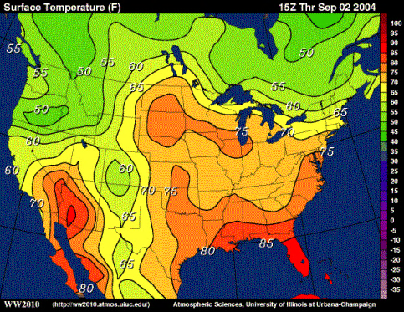

Procedure A – Isotherm Map
- Locate the lowest temperature measurement, in multiples of 10°F and connect each of these points with a circle.
  - Keep lower temperatures inside the circle and higher temperatures outside the circle. The circle will not be perfect but move in the direction of closer neighboring temperature measurements, 10 is closer to 13 than it is 20.
- Continue to connect similar temperature measurements in multiples of 10 until you have come to the highest temperature on the map.
  - Not all isotherm lines will connect to form a circle. Many will start on the edge of the map and end at the edge of the map creating just a curved line.
- Color your map according to the Key.

Analysis:

- Define Isotherm: _________________________________________________________
________________________________________________________________________

- Why are they used? _______________________________________________________
________________________________________________________________________
________________________________________________________________________

- What color temperature range does New York fall within? ________________________

- Based on your map, in which direction would you head from New York to find warmer temperatures? ___________________________________________________________

- Based on your map, what should people in New York expect to happen to their temperatures over the next few days? ________________________________________

Isobars
Isobars are lines of constant or equal pressure on a weather map. They can be used to find areas of low or high pressure over a broad area (like the U.S.), and they can tell us how intense the system may be. On weather maps, you may have noticed areas that have a large “L” or “H” over a region with lines circling around them. The “L” stands for low pressure and “H” stands for high pressure. The lines circling them are isobars. Generally the lowest pressure is where precipitation is most likely to fall, and high pressures are usually associated with clear and sunny conditions. Where the isobars are close together, windy conditions may be expected. Pressure systems always move from areas of high pressure to areas of low pressure and in the United States, usually from West to East.

Isobar lines are drawn in increments of 4mb, starting from the 1000mb point. Anything located inside the circle, connecting all of the similar 1000mb measurements, would have pressure readings lower than 1000mb. Anything between the 1000mb and the next 4mb pressure reading, 1004mb, would have pressure readings of 1001, 1002, or 1003mb.

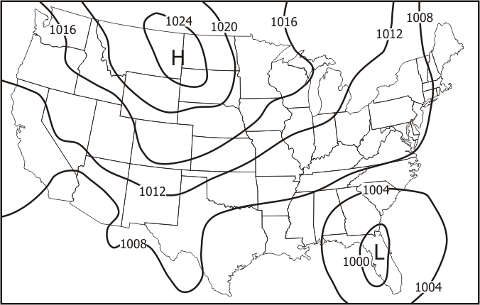

Procedure B – Isobar Map
- Locate the 1000 mb isotherm and connect each of the points with a circle.
  - Remember, the circle will not be perfect but move nearer to points of closer pressure measurements and farther from points of more distant pressure measurements.
- Continue to connect isolines around pressure measurements in increments of 4 mb.
  - Some pressure measurements will not form a circle but start and end on the edges of the map.
- Label the low pressure center with an “L”.
- Label the high pressure center with an “H”.

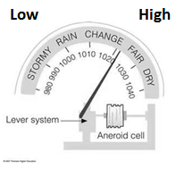

Analysis:

- Over what state is the high pressure center located? ____________________________

  - What pressure reading was recorded here and what weather conditions would they be experiencing at this time? ______________________________________
__________________________________________________________________

- Over what part of the United States is the low pressure center located? _____________
________________________________________________________________________

  - What pressure reading was recorded here and what weather conditions would they be experiencing at this time? ______________________________________
__________________________________________________________________

- Over the next few days, what could people in New York expect to happen to the barometric pressure and what weather conditions would be moving in? _____________
________________________________________________________________________
________________________________________________________________________

