Name ________________________________________ Date __________ Block ___________

Identifying Rocks

- Rocks
Rocks are a mixture of minerals and other materials. For instance granite is a combination of quartz, feldspar, mica and hornblende. Geologists study and classify rocks based on their color, texture and mineral composition.
Texture is the look and feel of the rock’s surface based on its grain size, shape and pattern. Grain size can be coarse, fine or have no visible grains. Grain shape can be rounded or jagged. Grain pattern can be banded or non-banded.
There are three major groups of rocks; Igneous, Sedimentary and Metamorphic.

Analysis:
- What are rocks made up of? _______________________________________________
______________________________________________________________________

- What do Geologists study and classify rocks based on? ___________________________
________________________________________________________________________

- Define texture: ___________________________________________________________
________________________________________________________________________
  - What is texture based on? ____________________________________________
__________________________________________________________________

- Igneous Rocks
Igneous rocks are formed directly by the cooling and crystallization of the extremely hot liquid rock material, magma or lava. They are the first type of rock to have formed on Earth. The word “Igneous” is Greek for fire. The rate of cooling determines the size of the crystals formed and the grain size; fast = no crystals and fine grain, moderate = small crystals and slow = large crystals with coarse grains. Igneous rocks formed at the surface of Earth, from lava, are classified as extrusive. While igneous rock formed within Earth’s surface, from magma, is classified as intrusive. Igneous rocks also have a range of color due to the mineral concentration within it. Igneous rocks that are dark in color are called mafic and contain the minerals iron and magnesium. Igneous rocks that are lighter in color are called felsic and contain aluminum. Igneous rocks can have a range of grain sizes with fined grained igneous rock forming by rapid cooling and coarse grained by slow cooling.

Analysis:
- Define Igneous: __________________________________________________________
________________________________________________________________________
  - What does Igneous mean? ____________________________________________

_____ 2. An igneous rock formed at Earth’s surface, from lava are classified as:
- intrusive b. extrusive c. felsic d. mafic

_____ 3. Igneous rocks that are dark in color and contain iron and magnesium are called:
- intrusive b. extrusive c. felsic d. mafic

_____ 4. Igneous rocks that are light in color and contain aluminum are called:
- intrusive b. extrusive c. felsic d. mafic

_____ 5. Igneous rocks formed within Earth’s surface, from magma, are classified as:
- intrusive b. extrusive c. felsic d. mafic

Making Connections – Use the chart to identify the characteristics of the igneous rock listed.
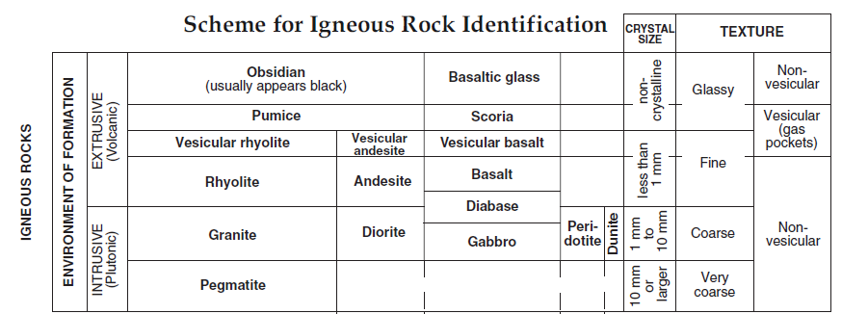

Name | Crystal Size | Intrusive/Extrusive | Texture
- Obsidian
- Pumice
4. Basalt
5. Rhyolite
7. Granite
11. Gabbro

12. An igneous rock that is very coarse, non-vesicular, intrusive with a crystal size of 10mm
or larger would be: _______________________________________________________

- Sedimentary Rocks
Sedimentary rocks are composed of particles of other rocks or the remains of plants and animals that have been compacted and cemented together. These particles were deposited in layers by water, wind and/or ice. Sedimentary rocks are classified into 3 categories based on what they are made of and how they formed: Organic – formed from the shells or body parts of once living things; plants and animals. Chemical – formed when elements dissolved in water came out of solution. The process of an element precipitating out of a solution is called chemical precipitation and form evaporites. Clastic – formed when particles that were weathered from other rocks were cemented together. These rocks are classified on the basis the size of the sediment particles that make up the rock.

Analysis:
- What are sedimentary rocks composed of? ____________________________________
________________________________________________________________________

_____ 2. Clastic A. formed from shells and/or body parts of once living
things.
_____ 3. Organic B. formed from weathered rock particles cemented
together.
_____ 4. Chemical C. formed from dissolved elements coming out of
solution.

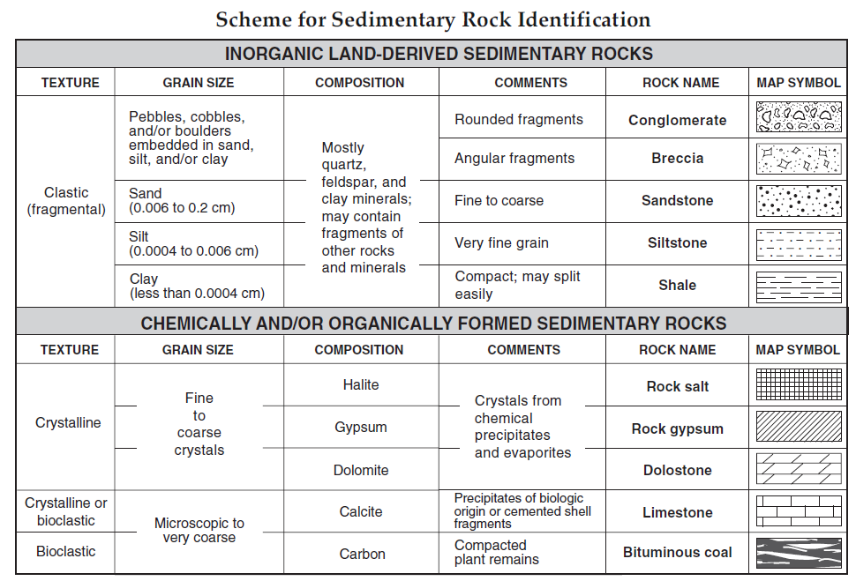
Making Connections - Use the chart to identify the characteristics of the sedimentary rock listed.

Name | Texture | Grain Size | Composition
16. Conglomerate
17. Sandstone
19. Shale
20. Bituminous Coal
21. Limestone
22. Dolostone
24. Gypsum

Matching - Use the Map Symbols to identify the rocks listed below.
_____ 12. Breccia A. B.

_____ 13. Siltstone
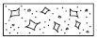
_____ 14. Rock Gypsum C. D.

_____ 15. Rock Salt

- Metamorphic Rocks
Metamorphic rocks are “changed rocks.” They were once other types of sedimentary, igneous, or metamorphic rock but have had their texture, structure and composition changed by heat, pressure and/or chemical reactions. They may still possess some of the characteristics of the rocks from which they were made. As a result, it is easy to make a mistake in the rock’s classification.
Texture is the difference in orientation, or alignment, of the crystals and the size of the crystals determine the texture of a metamorphic rock. There are to general texture groups/ foliated and non-foliated. Foliated textures are those in which platy or leaf-like minerals (mica or chlorite) are nearly all aligned parallel to one another. As a result, the rock splits readily along the well-oriented, nearly parallel cleavages of its mineral particles. Non-foliated textures are composed of either randomly oriented platy minerals or minerals that are not foliated. Non-foliated metamorphic rocks will break into angular pieces. Many times metamorphic rocks that are non-foliated are called massive. Marble and quartzite are examples of massive non-foliated metamorphic rocks.

Analysis:
- What does Metamorphic mean? ____________________________________________

- What factors played a role in changing the texture, structure and composition of a rock?

- Mica and chlorite are both examples of metamorphic rock with this type of texture: ________________________________________________________________________

- What are two examples of massive non-foliated metamorphic rock: _______________
________________________________________________________________________

Making Connections - Use the chart to identify the characteristics of the sedimentary rock listed.
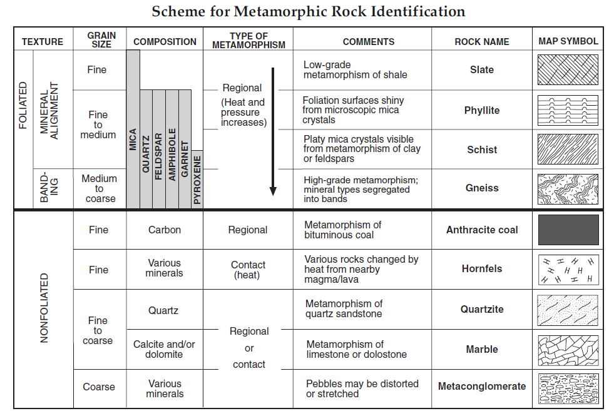

Name | Texture | Grain Size | Comments/  Metamorphism of:
25. Gneiss
27. Schist
28. Phyllite
30. Quartzite
32. Slate
33. Marble
35. Hornfels
Matching - Use the Map Symbols to identify the rocks listed below.
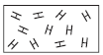
_____ 12. Metaconglomerate A. B.

_____ 13. Phyllite
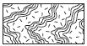
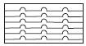
_____ 14. Hornfels C. D.

_____ 15. Gneiss

The Rock Cycle
The rock cycle is a series of processes that slowly change rocks from one kind to another. It builds, destroys and changes the rocks in the crust and is driven by plate tectonics.

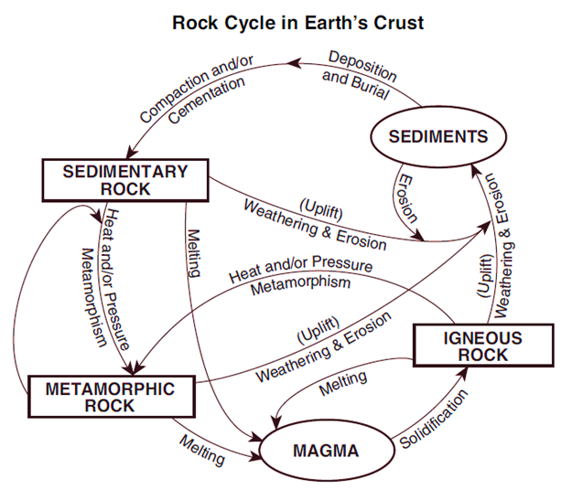
Analysis:

1. Identify two processes most directly involved in the formation of sedimentary rock from sediments.
a.
b.

2. What type of rock forms directly from magma?

3. Heat and/or Pressure and Metamorphism produce this type of rock:

4. What process is most directly involved in changing igneous rock into sediments?

5. The melting and solidification of sedimentary rock would produce what type of
rock?

_____ 6. What heading would best describe the information in the second column?
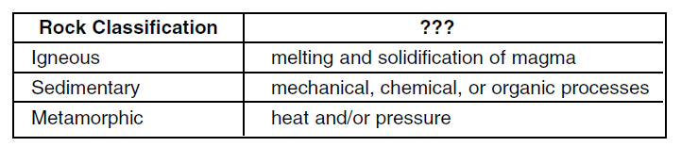

a. Minerals in rocks b. Method of Rock Formation
c. The Value of Rocks d. The Time Rocks Take to Form

