Name _________________________________________________ Date __________ Block __________

**Identifying New Pamishan Creatures**

**Dichotomous Keys**

**Classification** is the process of grouping things based on their similarities. Biologists use classification to organize living things into groups so that the organisms are easier to study. The scientific study of how living things are classified is called **taxonomy**. **Binomial nomenclature** is the system used to name organisms by giving the organism a two part name. The first part of the organism’s name is its **genus**. A genus is a classification grouping that contains similar, closely related organisms. This is much like your last name. The second part of the organism’s name is its **species**. A species is a group of similar organisms that can mate and produce fertile offspring. This is much like your first name.

To identify an organism you can either use a field guide or a taxonomic key. Field guides are books with illustrations that highlight differences between similar looking organisms. A taxonomic key is a series of paired statements that describe the physical characteristics of different organisms. **Dichotomous keys** are used to identify an unknown organism based on pairs of opposing statements that guide you through the observable characteristics of that organism. As you work your way through a dichotomous key you eventually identify the organism as an individual based on the statements that were true for that organism.

Use the following dichotomous key to try to figure out the names of the 20 aliens pictured below.



**A Key to New Pamishan Creatures**

|  |  |
| --- | --- |
| 1. | a. The creature has a large wide head............................go to 2 |
|  | b. The creature has a small narrow head..........................go to 11 |
| 2. | a. It has 3 eyes ................................................go to 3 |
|  | b. It has 2 eyes ................................................go to 7 |
| 3. | a. There is a star in the middle of its chest....................go to 4 |
|  | b. There is no star in the middle of its chest ..................go to 6 |
| 4. | a. The creature has hair spikes .................................***Broadus hairus*** |
|  | b. The creature has no hair spikes...............................go to 5 |
| 5. | a. The bottom of the creature is arch-shaped ....................***Broadus archus*** |
|  | b. The bottom of the creature is M-shaped .......................***Broadus emmus*** |
| 6. | a. The creature has an arch-shaped bottom .......................***Broadus plainus*** |
|  | b. The creature has an M-shaped bottom...........................***Broadus tritops*** |
| 7. | a. The creature has hairy spikes ................................go to 8 |
|  | b. The creature has no spikes....................................go to 10 |
| 8. | a. There is a star in the middle of its body ....................***Broadus hairystarus*** |
|  | b. The is no star in the middle of its body .....................go to 9 |
| 9. | a. The creature has an arch shaped bottom .......................***Broadus hairyemmus*** |
|  | b. The creature has an M shaped bottum ..........................***Broadus kiferus*** |
| 10. | a. The body is symmetrical ......................................***Broadus walter*** |
|  | b. The body is not symmetrical...................................***Broadus anderson*** |
| 11. | a. The creatrue has no antennae .................................go to 12 |
|  | b. The creature has antennae ....................................go to 14 |
| 12. | a. There are spikes on the face .................................***Narrowus wolfus*** |
|  | b. There are no spikes on the face ..............................go to 13 |
| 13. | a. The creature has no spike anywhere ...........................***Narrowus blankus*** |
|  | b. There are spikes on the right leg ............................***Narrowus starboardus*** |
| 14. | a. The creature has 2 eyes.......................................go to 15 |
|  | b. The creature has 1 eye........................................***Narrowus cyclops*** |
| 15. | a. The creature has a mouth......................................go to 16 |
|  | b. The creature has no mouth.....................................go to 17 |
| 16. | a. There are spikes on the left leg .............................***Narrowus portus*** |
|  | b. There are no spikes at all ...................................***Narrowus plainus*** |
| 17. | a. The creature has spikes ......................................go to 18 |
|  | b. The creature has no spikes ...................................***Narrowus georginia*** |
| 18. | a. There are spikes on the head .................................go to 19 |
|  | b. There are spikes on the right leg.............................***Narrowus montanian*** |
| 19. | a. There are spikes covering the face ...........................***Narrowus beardus*** |
|  | b. There are spikes only on the outside edge of head ............***Narrowus fuzzus*** |

1. **Dichotomous Key**: Use the Key on the previous page to name each of the New Pamishan Creatures correctly.
2. _________________________________________________________________________
3. _________________________________________________________________________
4. _________________________________________________________________________
5. _________________________________________________________________________
6. _________________________________________________________________________
7. _________________________________________________________________________
8. _________________________________________________________________________
9. _________________________________________________________________________
10. _________________________________________________________________________
11. _________________________________________________________________________
12. _________________________________________________________________________
13. _________________________________________________________________________
14. _________________________________________________________________________
15. _________________________________________________________________________
16. _________________________________________________________________________
17. _________________________________________________________________________
18. _________________________________________________________________________
19. _________________________________________________________________________
20. _________________________________________________________________________
21. _________________________________________________________________________
22. **Analysis**
23. **Matching** – Put the letter of the correct answer in the space provided.

_____ 1. Classification A. A group of similar organisms that can mate and produce

fertile offspring.

_____ 2. Taxonomy B. The system used to name organisms by giving them a two

part name.

_____ 3. Binomial Nomenclature C. The process of grouping things based on their similarities.

_____ 4. Genus D. The scientific study of how living things are classified.

_____ 5. Species E. A grouping that contains similar, closely related organisms.

1. **Multiple Choice** – Put the letter of the correct answer in the space provided.

_____ 6. An example of a **genus** in this lab would be:

1. *Broadus* b. *Narrowus* c. *hairus* d. both A & B

_____ 7. An example of a **species** in this lab would be:

1. *Broadus* b. *Narrowus* c. *hairus* d. both A & B

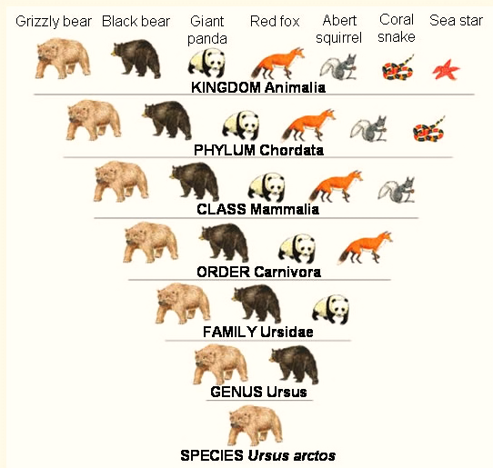

_____ 8. The largest and most general grouping

of organisms is the:

1. Genus b. Species

c. Kingdom d. Family

_____ 9. **Mammalia** is this level of classification:

1. Genus b. Class

c. Kingdom d. Family

_____ 10. What **Family** does the Grizzly bear

belong to?

1. Chordata b. Ursus

c. Carnivora d. Ursidae

_____ 11. ***Ursus arctos*** is the Grizzly bear’s:

1. Genus, Species b. Species, Genus

c. Kingdom, Class d. Family, Phylum