Name _________________________________________ Date _________ Block _________

Mineral Identification
Activity

Minerals are pure substances that are made up of only one type of matter through the process of crystallization, the process by which atoms are arranged to form a material with a crystal structure.
The crystallization of a melted material, lava or magma, can be drastically different depending on where the cooling process took place; deep, shallow or at Earth’s surface. Magma cooling deep within a volcano will cool at very slow rates thus forming large crystals. Magma forming within a vent of a volcano will cool faster and have smaller crystals. Lava cooling at Earth’s surface will cool so fast that no crystals will have time to form.
Crystallization can also occur from materials dissolved in water. Calcite is a mineral that forms from the chemical weathering process by carbon dioxide and oxygen.
Characteristics of all minerals are naturally occurring, inorganic and have a chemical composition. Minerals can consist of a single atom, element, like gold (Au), silver (Ag) or Iron (Fe) or they can consist of two or more elements combined, compound, calcite (CaCO₃) or Talc (Mg₃Si₄O₁₀(OH)₂). A mineral can be identified using a series of tests to determine the mineral’s hardness, streak, luster and cleavage. Hardness is the mineral’s resistance to being scratched, 1 = softest (talc) and 10 = hardest (diamond). Streak is the color of the powder left after the mineral is rubbed onto a piece of porcelain tile. Luster is the ability of the mineral to shine or reflect light; shiny or dull. Cleavage is the tendency of the mineral to break along regular surfaces in one or more directions.
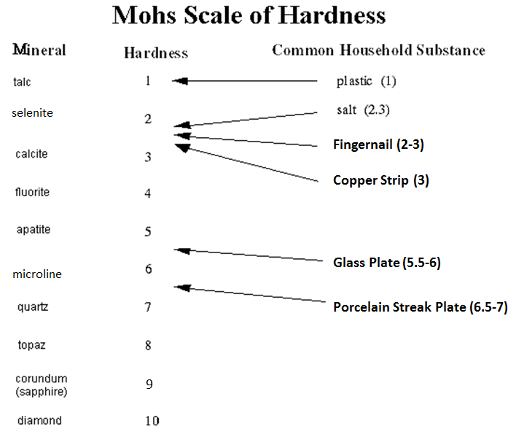

Using the box of minerals provided, identify each of the minerals by putting it through the tests listed in the data table below.
Luster  (Shiny or Dull) | Cleavage  (1 directional or multiple) | Streak  Color | Hardness | Mineral Name
 |  |  |  | - Talc
 |  |  |  | - Selenite
 |  |  |  | - Calcite
 |  |  |  | - Fluorite
 |  |  |  | - Apatite
 |  |  |  | - Microline
 |  |  |  | - Quartz
 |  |  |  | - Topaz
 |  |  |  | - Corundum

Analysis:

- What are minerals? _______________________________________________________
________________________________________________________________________

- What are the three characteristics of all minerals?

- Define element - __________________________________________________________
________________________________________________________________________

- Define compound - ________________________________________________________
________________________________________________________________________

Matching – Put the letter of the correct answer in the space provided.

_____ 5. Streak A. The tendency of a mineral to break along regular
surfaces.
_____ 6. Luster B. The resistance of a mineral to being scratched.

_____ 7. Hardness C. The color of the powder left after being rubbed on a
tile.
_____ 8. Cleavage D. The ability of a mineral to shine or reflect light.

Multiple Choice – Put the letter of the correct answer in the space provided.

_____ 9. The process by which atoms are arranged to form a material with a crystal
structure:
a. cleavage b. element c. crystallization d. luster

_____ 10. Which of the following is NOT an example of an element?
a. CaCO₃ b. Au c. Ag d. Fe

_____ 11. CaCO₃ and Mg₃Si₄O₁₀(OH)₂ are both examples of a:
a. element b. mineral c. compound d. both B & C

_____ 12. A mineral that can be scratched by salt but not by plastic is:
a. calcite b. topaz c. talc d. diamond

_____ 13. A mineral that can be scratched by a porcelain streak plate but not a glass plate
is:
  - apatite b. microline c. selenite d. calcite

Making Connections – Use the diagram to answer the questions that follow.
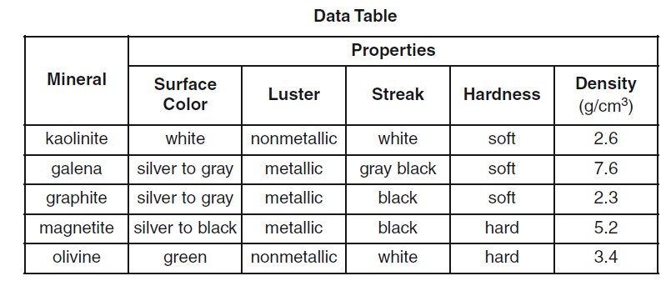

14. This mineral is silver to black, has a metallic luster and is hard: ____________________
a. Its density is: ________________
- Would it sink or float in water, Why? ________________________________
_______________________________________________________________

15. This mineral is soft, has a white streak and is white in color: _______________________

16. What characteristic, other than density, separates galena from graphite? ____________

