Name __________________________________________ Date __________ Block __________

Identifying Forces
LAB

A force is a push or pull that starts, stops or changes the direction of an object. Force can be described by how strong it is and in what direction it is being applied. The formula for force is the mass of an object times its acceleration (F = m X a). The unit given to force is called a Newton, kg x m/s², and is named after Sir Isaac Newton. A Newton is the amount of force needed to cause a 1 kg mass to accelerate at a rate of 1 m/s/s.
Force is affected by two other components; gravity and friction. All objects are pulled toward the Earth’s surface at an acceleration of 9.8 m/s², the force of gravity. So your weight is really the amount of matter that makes up your body times the gravitational force that is holding it to Earth’s surface (weight = mass X gravity). Friction is a force that works in the opposite direction that an object is moving. There are three types of friction that work against an object; rolling friction, fluid friction and sliding friction. A product of friction is heat. The rougher a surface is the greater the frictional force, the smoother a surface is the frictional force is reduced. To help reduce friction people often apply lubricants to objects so that they work more efficiently.

Analysis:

- Define force: _____________________________________________________________
________________________________________________________________________
  - What are two ways that force can be described?
    - ___________________________________________________________
    - ___________________________________________________________

- What is the formula for finding force? ________________________________________
  - What unit is used to describe force? ___________________________________

- What two other components affect force?
  - __________________________________________________________________
  - __________________________________________________________________

- Define friction: ___________________________________________________________
________________________________________________________________________

  - What is a product of friction? _________________________________________

- Gravity
A spring scale is an instrument that can be used to measure the effect of gravity (9.8 m/s²) on an object. Objects with larger amounts of mass stretch the spring farther than objects with less mass.

- Use the spring scale to determine the force needed to lift each mass.

Mass  (g) | Force  (N)
0g
50g
100g
200g

Analysis:

- All object’s fall to the surface of Earth at an acceleration of: _______________________

- Friction
The texture of different surfaces can cause an object to move with different amounts of force due to friction. Use each of the following materials to test the force needed to overcome the friction caused by that material.

- Attach the wood block to a spring scale and slide it across the length of the desk with each of the different masses listed.
  - Record the measured force (N) on the data table below.
- Repeat this same procedure using: sandpaper, wax paper and plastic

 | Wood | Sandpaper | Metal | Plastic
0g
50g
100g
200g

Analysis:

- Which surface had the greatest frictional force? ________________________________

- Which surface had the least frictional force? ___________________________________

- Force
The ramp can be used to demonstrate the effects of velocity on the distance an object can be moved.
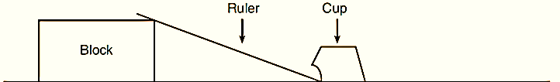

Books

- Roll the marble from each of the indicated distances on the metric ruler.
  - Repeat each roll three times and calculate the average for each roll.
    - Record data on the data table provided.

Marble Release  (cm) | Cup Movement  Trial #1  (cm) | Cup Movement  Trial #2  (cm) | Cup Movement  Trial #3  (cm) | Average  (cm)
5
10
20

Analysis

- As you increased the distance the marble rolled, what happened to the distance the cup moved? _________________________________________________________________

- At what height did the marble have the:
  - Greatest potential energy: ____________________________________________

  - Least potential energy: _______________________________________________

_____ 3. What rule of kinetic energy does this best demonstrate?
- Double mass, doubles kinetic energy.
- Double velocity, quadruples kinetic energy.
- Double mass, kinetic energy stays the same.
- Double velocity, kinetic energy stays the same.

Making Connections – Use the diagrams to answer the questions that follow.

_____ 1. The diagram below shows a spring scale being used to weigh a 100g mass.
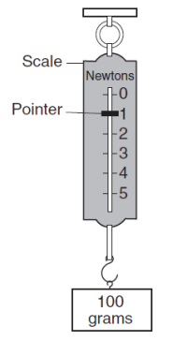

Which diagram best represents the correct reading for the same spring scale being used to weigh a 200g mass?
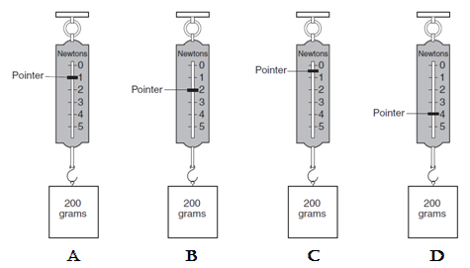

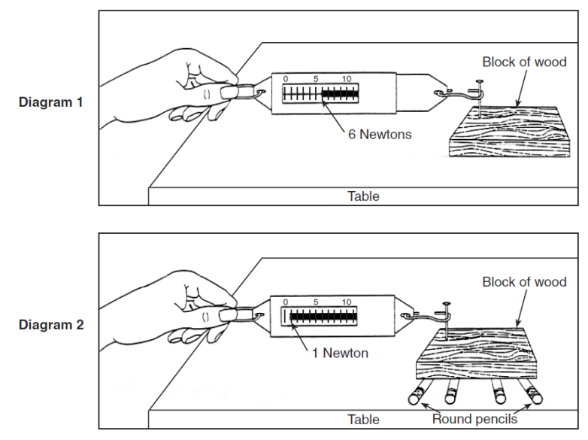
- What is the name of the device being
used in the diagram to the right to measure
force?

- How much force was needed to move:
  - The block of wood on the table?

  - The block of wood on the pencils?

- What two changes could be made in
the setup in diagram 1 to increase the
amount of force necessary to move the
block of wood?

- Explain why the pencils in diagram 2 decrease the amount of force necessary to move the block of wood.

  - What type of friction does this best demonstrate?
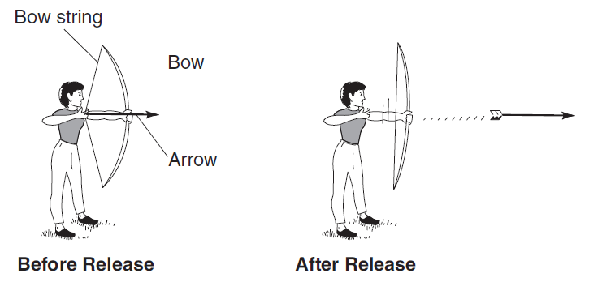

- What type of energy does the arrow have before release? ________________________

- State one change that could be made, other than changing the angle the bow is held, that would allow the arrow to travel a greater distance. __________________________
________________________________________________________________________

- What two factors would affect the path of the arrow after it is released?
  - ___________________________________________________
  - ___________________________________________________
______________________________________________________________________________
_____ 10. The diagram below shows smooth blocks of wood being pushed across the same surface. The mass of the block and the amount of force applied are labeled in each diagram. In which diagram would the block of wood have the greatest acceleration.
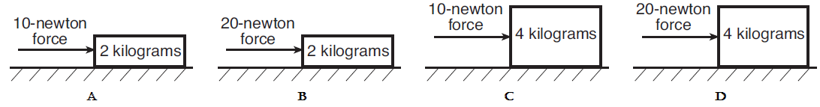

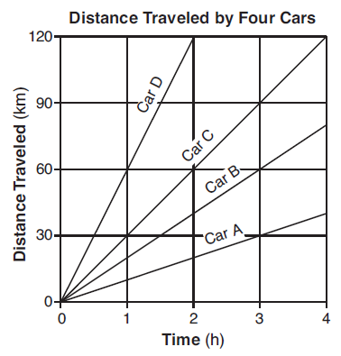
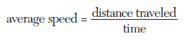

_____ 11. Which car traveled at an average speed of
20 km/hr?
- Car A b. Car B
c. Car C d. Car D

If both Student A and Student B have an acceleration of 9.8 m/s/s, what would each student’s velocity be, upon hitting the water, after each second of their jump?
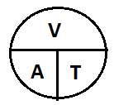
Acceleration = Velocity/Time

Student A
Time  (S) | 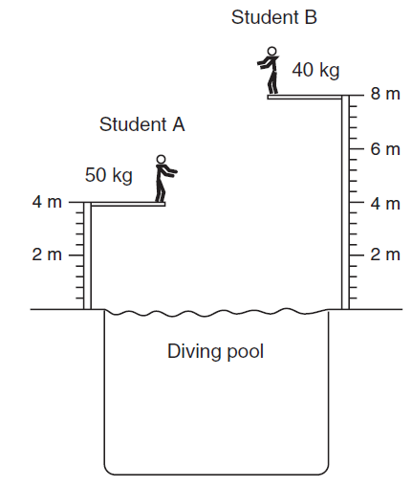  Velocity  (m/s)
1
2
3
4

Student B
Time  (S) | Velocity  (m/s)
1
2
3
4
5
6
7
8

