Name ___________________________________________ Date _________ Block __________

**Systems of the Human Body**

**Levels of Organization**

Cells are the basic units of live in all living things. You have about 200 different types of cells that make up the trillions inside your body. Each type of cell must work with the other types to allow an organism to grow, develop, repair, reproduce and remain healthy. All multicellular life has a level of organization that occurs with the cells that work together to create a living thing.

From the most simple to the most complex the levels of organization are as follows:

**Cells** are the smallest and most specialized.

* Red blood cells transport oxygen to cells and carbon dioxide away from cells.
* Chloroplasts convert light energy into chemical energy.

Plant Cell Animal Cell

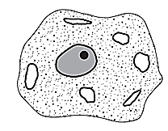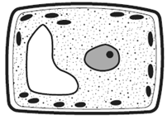

**Tissues** are groups of cells that perform the same function.

* Blood is a tissue due to the fact it has red blood cells, white blood cells, platelets and plasma all working together to carry nutrients and wastes to and from the cells.
* Vascular tissue is made up of both xylem cells and phloem cells working together.

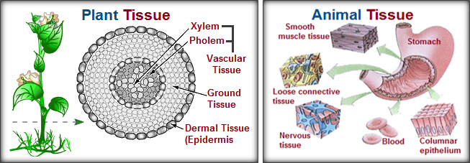

**Organs** are groups of tissues that work together to perform certain functions.

* The heart is an organ composed of muscle tissue, nervous tissue and blood tissues. They all work together to pump the blood throughout the body.
* Roots anchor the plant and absorb water and minerals from the soil while transporting substances to the stem.

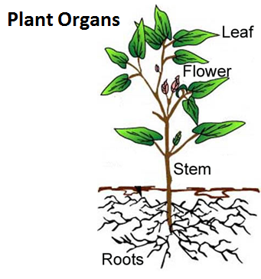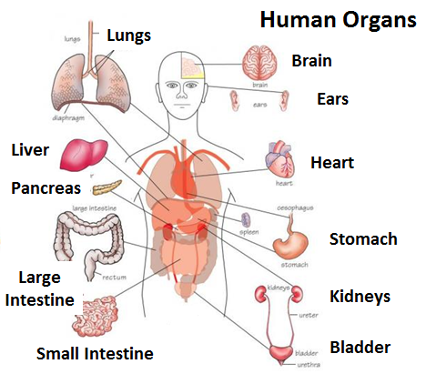

**Organ Systems** are groups of organs that work together to perform specific functions.

* The circulatory system consists of the heart, arteries, veins and capillaries that work to transport materials throughout the body.
* 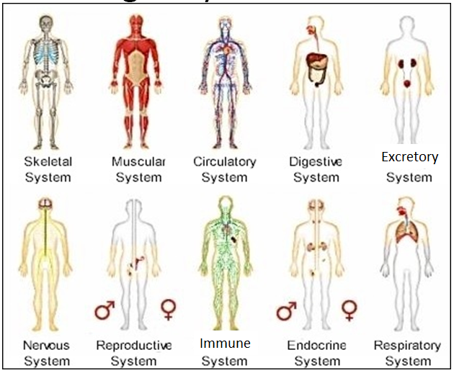Flowers contain both the stamen and carpal that make up the reproductive system of the plant.

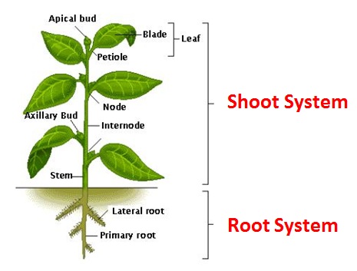

**Organism -** the entire, most general group.

* 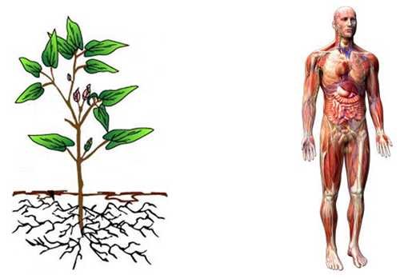The human
* The Plant

**Analysis:**

1. **Matching** – Put the letter of the correct answer in the space provided.

_____ 1. Cell A. Organs working together to perform a set of related

tasks.

_____ 2. Tissue B. An entire living thing that carries out all the basic life

functions.

_____ 3. Organ C. A group of similar tissues performing a job.

_____ 4. Organ System D. The basic unit of structure and function of all living

things.

_____ 5. Organism E. A group of similar cells doing the same job.

1. **Multiple Choice** – Put the letter of the correct answer in the space provided.

_____ 6. Which sequence lists the levels of organization in their correct order, from

simplest to most complex?

1. tissue, cell, organ, organ system b. organ system, tissue, cell, organ

c. cell, tissue, organ, organ system d. organ, organ system, tissue, cell

_____ 7. Leaf, Kidneys, Heart and Stem all make up:

1. tissues b. organ systems c. cells d. organs

_____ 8. Which of the following is NOT an example of a tissue?

1. root system b. blood c. vascular tissue d. nervous tissue

_____ 9. Photosynthesis, reproduction, storage, transport and hormones are all functions

of the:

1. shoot system b. root system c. circulatory system d. excretory system
2. **Making Connections** – Use the diagram to answer the questions that follow.

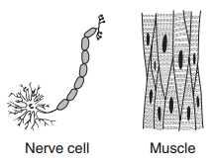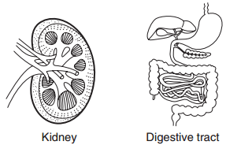_____ 10. Cell  **A. B. C. D.**

_____ 11. Tissue

_____ 12. Organ

_____ 13. Organ System

**Neuron**

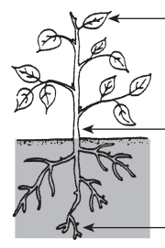

**Leaf**

**Stem**

**Roots**

Which part of the plant above performs the following functions?

________________ 14. Absorption of water and nutrients, anchors plant.

________________ 15. Photosynthesis, absorbs sunlight, produces food.

________________ 16. Support, transports water and nutrients.

17. What parts make up the **shoot system**: _______________________________________

18. What part makes up the **root system**: ________________________________________

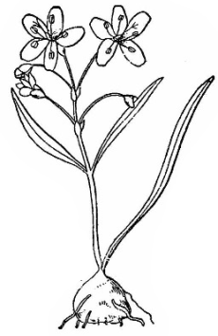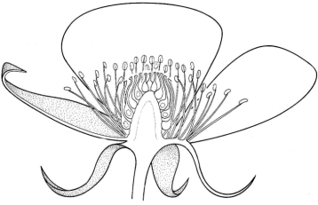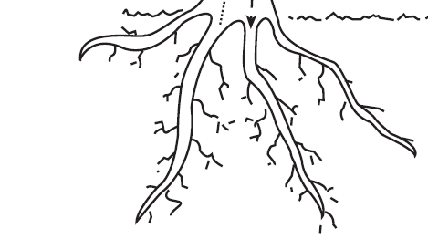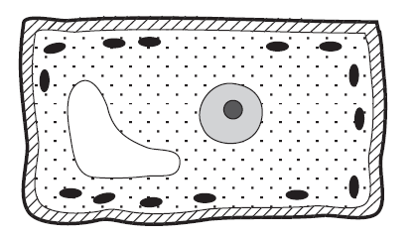

Xylem Lateral & Primary Roots Flower

Spring Beauty

1. Which diagram above represents an **organ system** of a plant? _____________________
2. Which diagram above represents a **cell** in a plant? _______________________________
3. Which diagram above represents an **organism**? _________________________________
4. Which diagram above represents an **organ** in the plant? __________________________

**Human Systems**

The human body is composed of ten different systems that are interconnected and work together to keep an organism functioning properly. When one system stops working properly the entire organism is affected.

**Digestive System** – Breaks down food into similar parts for the absorption and use of nutrients by the body.

Food enters the **mouth** where it is mechanically broken down through chewing and chemically broken down by the addition of saliva. When food is swallowed it travels down the **esophagus** to the **stomach** where muscular contractions continue the process of mechanical digestion and some chemical digestion takes place. The food then travels into the **small intestine** where enzymes are released to further the process of chemical digestion and nutrients are passed into the blood stream. The portions of the food that cannot be used by the body pass into the **large intestine** where any excess water, that can be removed, is absorbed out. At this point any material left is in the form of a solid mass that the body releases as waste.

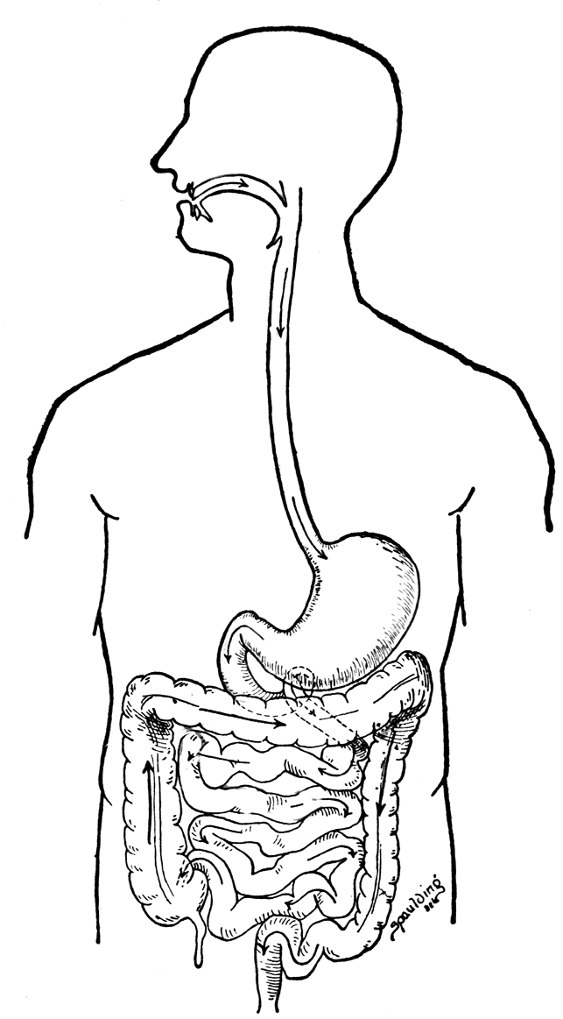**Analysis**:

1. _____________________________

**1**

1. _____________________________

**2**

1. _____________________________
2. _____________________________
3. _____________________________

**5**

**4**

**3**

1. Name two locations where **mechanical digestion** takes place? _____________________

________________________________________________________________________

1. In which of these locations does the majority of mechanical digestion take place? __ _____________________________________________________________________
2. Name two locations where **chemical digestion** takes place? _______________________

________________________________________________________________________

1. In which of these locations does the **majority of chemical digestion** take place? ___

_____________________________________________________________________

1. **Circle** the type of digestion taking place at each location named.

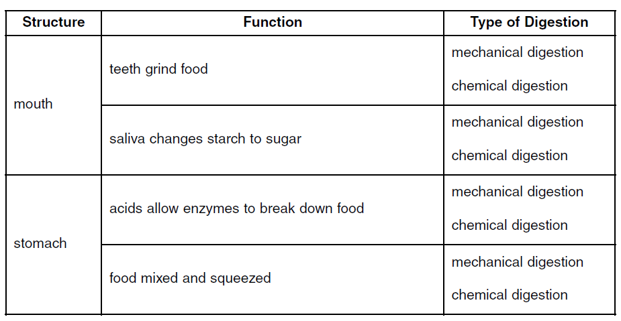

1. From the reading, name one other system of the human body that the digestive system works with, How? _________________________________________________________

________________________________________________________________________

**Respiratory System** – Brings in a fresh supply of oxygen while removing the waste products carbon dioxide and water.

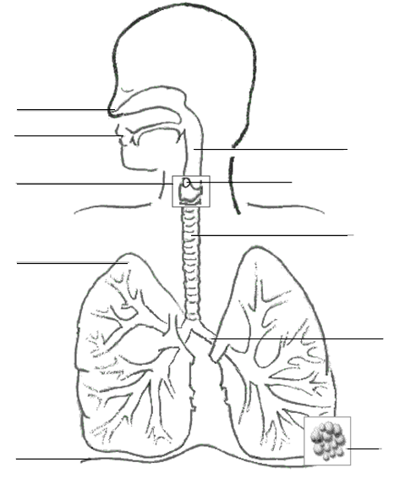Air enters the respiratory system through either the **nose** or the **mouth**. The nose is the healthiest opening for it cleans, warms and moistens the air as it passes through it. Air then moves down into the **trachea** and through the larynx into the **bronchi**. The bronchi split into the left and right lungs. **Lungs** are composed of millions of tiny grape-like clusters called **alveoli** that exchange the new oxygen for waste carbon dioxide and water, by diffusion, with the circulatory system of the body.

1. _________________________
2. _________________________

**2**

**1**

1. _________________________
2. _________________________

**4**

1. _________________________

**3**

1. _________________________

**5**

**6**

1. Which opening is the healthiest to breathe through? _____________________________
   1. Why? _____________________________________________________________

__________________________________________________________________

1. What process is used to exchange oxygen and carbon dioxide between the circulatory system and the respiratory system? __________________________________________
2. Name one other system of the human body that the respiratory system works with, How? ___________________________________________________________________

________________________________________________________________________

**Mechanics of breathing**: Air is moved into the respiratory system due to pressure difference inside and outside the body. When the lungs are empty, the air pressure inside them is lower than the air pressure outside the body. To equalize the pressure differences the diaphragm pulls down, by muscular contractions, while the ribs expand, also by muscular contractions, allowing for more space inside the chest cavity. Air is pulled into the lungs and you **inhale**.

When air is removed from the respiratory system the reverse occurs. The air pressure inside the lungs is higher than the outside environment. The diaphragm relaxes, moving up, and the ribs relax, moving down and in, reducing the amount of space available in the chest cavity. This pushes the air out of the lungs and you **exhale**.

**Analysis**:

1. Label the lung model below with the matching parts of the respiratory system: **lungs, diaphragm, trachea and rib cage**.

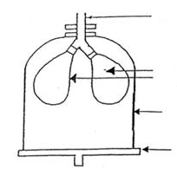

1. What is the main cause of air moving into and out of the respiratory system? _______

________________________________________________________________________

1. When we **breathe in**, what are the air pressure differences between the outside and inside of the body? ________________________________________________________

________________________________________________________________________

1. When we **breathe out**, what are the air pressure differences between the outside and inside of the body? ________________________________________________________

________________________________________________________________________

**Circulatory System** – “The River of Life”, moves substances throughout the body.

The circulatory system is composed of three different parts: The heart, the blood and the blood vessels.

The heart is a muscular organ that pumps blood throughout the body. It is composed to two loops: heart-lung-heart loop and heart-body-heart loop. The **heart-lung-heart loop** is comprised of high carbon dioxide blood that is returning from its trip around the body. The primary function of this loop is to deliver this blood to the lungs where it will exchange the carbon dioxide for a new supply of oxygen through the process of diffusion in the capillaries. Once the blood has a fresh supply of oxygen it goes back to the heart so that it can be sent out to deliver this oxygen to the cells of the body.

The **heart-body-heart loop** is comprised of high oxygen blood that is being delivered to the cells of the body for the process of respiration. At the same time the oxygen is delivered carbon dioxide is being picked up, through the capillaries by diffusion, and will be brought back to the heart for removal from the body.

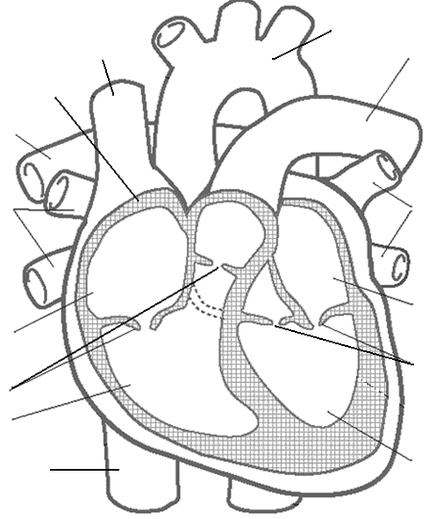 **Right Left**

**12**

**11**

_____ A. Pacemaker

**1**

**10**

_____ B. Valves

_____ C. Aorta

**1**

_____ D. Inferior Vena Cava

_____ E Right Atrium

**2**

**2**

_____ F. Pulmonary Veins

_____ G. Left Ventricle

_____ H Superior Vena Cava

**3**

_____ I. Pulmonary Artery

**9**

**4**

_____ J. Septum

**4**

_____ K. Left Atrium

**8**

_____ L. Right Ventricle

**6**

**7**

**5**

1. What loop is comprised of carbon dioxide high blood, returning back to the heart from its trip around the body? __________________________________________________
2. What is the heart-body-heart loop comprised of? ______________________________

________________________________________________________________________

________________________________________________________________________

**Blood vessels** are what carry the blood throughout the body. Depending on the job that blood vessel has depends on how the vessel is designed. **Arteries** are always the thickest and strongest of the blood vessels for they are the vessels that carry blood away from the heart. Being that the heart is so strong, the blood leaving the heart is being pumped with a great deal of force. Arteries have the ability to expand and relax with heartbeats. **Capillaries** are the smallest and thinnest of the blood vessels. Their primary function is to exchange carbon dioxide and oxygen with the cells of the body and the lungs through a process called diffusion. To make this process possible, capillaries have holes that allow only carbon dioxide and oxygen to fit through and move between the alveoli and cells. **Veins** are the blood vessels that carry the blood back to the heart. Most of the time, veins are fighting gravity and therefore have valves that help them to prevent the blood from flowing backwards.

1. Blood vessels that carry blood **away** from the heart: _____________________________
2. Blood vessels that **exchange** materials with the body: ____________________________
   1. The process used for exchange is called: _________________________________
3. Blood vessels that carry blood **back** to the heart: ________________________________
   1. What feature do they have to help them with this process? _________________
4. Name one other system of the human body that the circulatory system works with, How? ___________________________________________________________________

________________________________________________________________________

Blood is composed of four different parts: red blood cells, white blood cells, platelets and plasma. The **red blood cells** make up the largest portion of the floating particles in the blood. Red blood cells contain a protein called hemoglobin that binds to oxygen and carbon dioxide and also makes blood red. **White blood cells** are the disease fighters of the body. They work with the immune system to keep the body healthy and disease free. **Platelets** are the “life savers” for they stop a person from bleeding at the site of a wound by forming blood clots. **Plasma** is the largest portion of whole blood and is composed of water, salts and proteins.

1. What are the **three floating particles** found in blood? ____________________________

________________________________________________________________________

1. What part makes up the largest portion of blood? _______________________________
   1. What is it mainly composed of? ________________________________________

There are four different blood types that occur in humans: A, B, AB and O. Blood type O is called the **Universal Donor** because it can be safely received by all other blood types. Blood Type AB is called the **Universal Recipient** because it can safely receive all blood types. Blood cells have antigens attached to them that like only the same blood type and have antibodies in the blood plasma that kills blood types that they don’t recognize.

|  |  |  |
| --- | --- | --- |
| **Blood Type** | **Likes** | **Kills** |
| **A** | **A & O** | **B & AB** |
| **B** | **B & O** | **A & AB** |
| **AB** | **A, B, AB & O** | **Nothing** |
| **O** | **O** | **A, B, & AB** |

1. What blood type is known as the **Universal Donor**? ______________________________
   1. Why? ____________________________________________________________
2. What blood type is known as the **Universal Recipient**? ___________________________
   1. Why? _____________________________________________________________

**Excretory System** - gets rid of excess water, dissolved salts and proteins.

The **kidneys** are the main filtration system of the body. As blood passes through the kidneys excess water, salts and other wastes are filtered out and removed. These waste products are carried down through the **ureter** to the **urinary bladder** where it is stored until ready to be removed from the body. The opening through which it leaves the body is called the **urethra**.

The skin is another organ of the excretory system. At times, your body can become too hot, and your skin can cool you off by evaporating away perspiration.

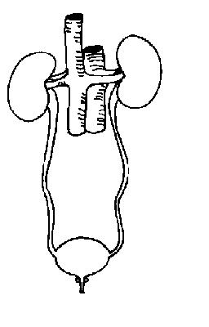

1. _______________________

**A**

1. _______________________
2. _______________________

**B**

1. _______________________

**C**

**D**

1. What are the **two** main organs of the excretory system? __________________________

________________________________________________________________________

1. Name one other system of the human body that the excretory system works with, How? ________________________________________________________________________

________________________________________________________________________

**Skeletal System** – protects and supports the internal organs of the body, provides movement, give an organism shape, stores minerals and produces new blood cells.

There are five different **joints**  types, locations where two bones meet, that allow your body to move in certain ways. **Immovable joints** don’t allow any movement at all. **Hinge** allows only back and forth movements, **ball and sockets joints** allow the greatest range of movement, **gliding joints** slide over one another and **pivot joints** rotate around each other.

**Bone Identification**:

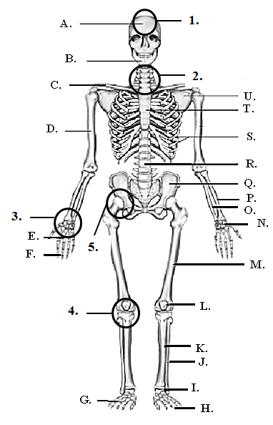_____ 1. Ribs

_____ 2. Cranium

_____ 3. Pelvic Girdle

_____ 4. Metacarpals

_____ 5. Femur

_____ 6. Tibia

_____ 7. Humerus

_____ 8. Mandible

_____ 9. Tarsals

_____ 10. Phalanges

_____ 11. Radius

_____ 12. Scapula

_____ 13. Vertebral Column

_____ 14. Clavicle

_____ 15. Ulna

_____ 16. Fibula

_____ 17. Metatarsals

_____ 18. Phalanges

_____ 19. Carpals

_____ 20. Sternum

_____ 21. Patella

**Joint Identification**:

_____ 1. Ball & Socket J

_____ 2. Hinge

_____ 3. Immovable

_____ 4. Pivot

_____ 5. Gliding

**Analysis**:

1. What are the functions of the skeletal system?
   1. _______________________________________________________
   2. _______________________________________________________
   3. _______________________________________________________
   4. _______________________________________________________
   5. _______________________________________________________
2. What type of joint allows the **greatest range of movement**? ______________________

**Muscular System** – allows the body to move.

You would not be able to stand upright if you didn’t have bones but you also wouldn’t be able to move unless you had muscles. Bones can only move if they work together with muscles and can move in different ways due to joints. But muscles have the ability to only contract and therefore must always work on pairs.

Muscles used to move the bones of the body are called **skeletal muscles**. They work by contracting, a voluntary action, to do the things you want to. Bones are held to other bones by **ligaments**, and to muscles by **tendons**. **Smooth muscle** is a type of muscle found inside the lining of your digestive tract and blood vessels. These are involuntary and you have no control over them. **Cardiac muscle** is found ONLY in the heart and is striated, banded, like skeletal muscle but involuntary like smooth muscle.

1. What type of muscle would you find in your **aorta**? ______________________________
2. What type of muscle would you find in your **biceps**? _____________________________
3. What type of muscle would you find in your **heart**? ______________________________
4. What do muscles have the ability to ONLY do? __________________________________
5. What holds **bone to bone**? _________________________________________________
6. 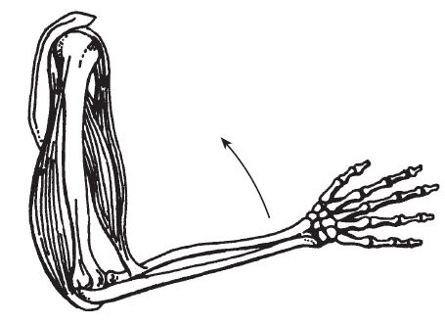For the arm to bend up, what action must the

bicep do? _____________________________

1. For the arm to straighten out, what action must **Bicep**

The triceps do? __________________________

**Triceps**

**Nervous System** – Sends and receives messages, both internally and externally, to allow for communication, regulate long and short term activities, and coordinate actions and process information.

The nervous system consists of the brain, spinal cord and sensory organs. The brain has three main sections: The **cerebrum** controls thought, learning and communication. The **cerebellum** controls balance and coordination. The **brain stem** control involuntary actions.

The spinal cord connects the brain to the rest of the body. The central nervous system consists of the brain and spinal cord together and the peripheral nervous system consists of a network of nerves that extend away from the brain and spinal cord.

The sensory organs are your eyes, ears, nose, skin, and taste buds. Each sensory organ has **sensory neurons** that pick up a stimuli and transfer the information to the spinal cord so that it can be interpreted by the brain, **interneuron**. Once the brain makes a decision as to how to handle the message it sends out a responds back to the muscle where the sensory neuron was located, **motor neuron**, and the appropriate response will take place. A **reflex** is an immediate and involuntary response to a stimulus.

**Analysis**:

1. If I was learning a different language what portion of my brain would I be using? ________________________________________
   1. Why? _____________________________________________________________
2. If I needed to jump from one rock to another to cross a stream without getting my shoes wet, what portion of my brain would I be using? ________________________________
   1. Why? _____________________________________________________________
3. My heart rate increases as I run, what portion of my brain is being used? _______________________________________
   1. Why? ____________________________________________________________

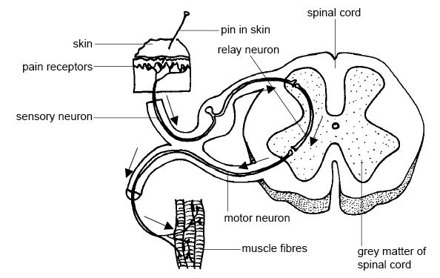

1. In the diagram to the right a pin has pricked my hand. In looking at the path of the message, what type of **response** would this trigger? _______________
   1. Is this voluntary or involuntary?
   2. Did the brain need to receive the message for a response to be sent out?

**Endocrine System** – Works directly with the nervous system to produce hormones that control specific body processes. The **hypothalamus** in the brain connects the nervous system and the endocrine system. The hypothalamus communicates directly with the **pituitary gland**, master gland, that directs the functions of other endocrine glands. The pancreas produces insulin that controls sugar levels in the bloodstream. When sugar levels are too high, insulin is produced to lower them. When sugar levels are too low, glucagon is released to increase the blood sugar levels. Testosterone and Estrogen are hormones produced by the male and female reproductive systems and trigger the production of secondary sex characteristics specific to each gender.

1. This endocrine gland is known as the “**master gland**”: ____________________________
2. This gland connects the nervous system and the endocrine system: _________________
3. What other system, other than the nervous system, does the endocrine system work with? How? ______________________________________________________________

________________________________________________________________________

**Immune System** – protects the body from disease and infection.

Your body has multiple defenses against disease and infection with the **first line of defense** being your skin. When intact it is the best defense against intruders. If the skin has an opening through which an intruder can enter your **second line of defense** is your inflammatory response, a quick invasion of white blood cells that attempt to destroy an invader it encounters. If the invader makes it past the inflammatory response your body can use its **last line of defense**, its memory of past illnesses to attempt to kill the invader. An active immunity is when a person has actually come down with an illness to create antibodies to, vaccines can also create active immunities. Passive immunity is when you receive a memory from an outside source. Babies receive immunities from their mother’s through breast milk and during development.

1. What is your body’s **first line of defense** against intruders? _______________________
2. What is your body’s **second line of defense** against intruders? _____________________
3. What makes up this second line of defense? __________________________
4. What is your body’s **last line of defense** against intruders? ________________________
5. What other system does the immune system work with? How? ____________________

_______________________________________________________________________

**Systems Working Together**

_____ 1. Bringing in a fresh supply of oxygen while removing the waste product carbon

dioxide, for the cells of the body, requires these two systems to work together:

1. skeletal and circulatory c. respiratory and circulatory
2. circulatory and digestive d. excretory and digestive

_____ 2. Bending your arm to lift an object requires these two systems to work together:

1. skeletal and circulatory c. digestive and excretory
2. skeletal and muscular d. respiratory and circulatory

_____ 3. Eating an apple and delivering its nutrients to the cells of the body requires these

two systems to work together:

1. skeletal and circulatory c. digestive and respiratory
2. respiratory and circulatory d. digestive and circulatory

_____ 4. Touching a hot pan and pulling your hand away from it requires these two systems

to work together:

1. nervous and muscular c. excretory and digestive
2. circulatory and excretory d. respiratory and reproductive

_____ 5. Seeing a dog growling at you and producing energy to run away requires these two

systems to work together:

1. circulatory and excretory c. skeletal and reproductive
2. nervous and endocrine d. digestive and muscular

6. Name the system of the human body that is being described in the “Life Activity” box.

