Name ______________________________________________ Date ________ Block ________

Heat Transfer Investigations

Station #1

Heat is a form of energy caused by the internal motion of molecules of matter. As a substance gains heat, the particles making it up move faster. This increased movement in turn causes the substance to have an increased volume and decreased density – thermal expansion. When a substance loses heat, the particles making it up move slower. This decreased movement in turn causes the substance to have a decreased volume and an increased density.

Analysis:
- Define heat: _____________________________________________________________
________________________________________________________________________

- When a substance loses heat, what happens to:

  - The particles making it up? ___________________________________________

  - It’s volume: ________________________________________________________

  - It’s density: ________________________________________________________

Making Connections:

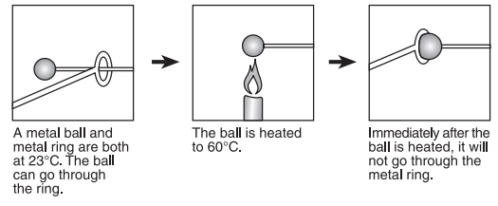
A B C

- What process is best being represented in the diagram above? ____________________

- In picture C, what is taking place with the ball’s:

  - Particles speed: ____________________________________________________

  - Volume: __________________________________________________________

  - Density: __________________________________________________________
Heat always moves from warmer objects to cooler objects by one of three methods of heat transfer; conduction, convection or radiation. Conduction is the transfer of heat from one particle to another through direct contact. This heat transfer always moves from the faster moving particle (hot) to the slower moving particle (cool). Conductors are substances that permit the flow of heat or electricity easily, while insulators are substances that do not permit the flow of heat or electricity easily. Convection is the transfer of heat by currents within a fluid; liquid or gas. The hotter the fluid the faster the particle movement and the less dense the material is thus making it rise. The cooler a fluid is the slower the particle movement and the more dense the material is thus making it sink. Radiation is the transfer of heat through empty space by electromagnetic waves. This type of heat transfer does not require matter for the heat to move.

Determine the type of heat transfer being demonstrated at each of the different stations.

Station #2

Two sets of jars have been set up with blue water, hot, and yellow water, cold. Set #1 has cold water on the bottom and warm water on the top. Set #2 has warm water on the bottom and cold water on the top.

- Color the set-ups to represent what you see on the teacher’s desk.

Set #1 Set #2

Cold
Hot

Cold
Hot

Hypothesis: What do you think, believe or feel will be the final result of the liquids after the teacher pulls the plastic from between each of the sets of jars, why? ______________________
______________________________________________________________________________
______________________________________________________________________________
______________________________________________________________________________
______________________________________________________________________________

- Color the final result for each set-up.

Set #1 Set #2

- Why do you think Set #1 had the final result it did? _____________________________
_______________________________________________________________________
_______________________________________________________________________

- Why do you think Set #2 had the final result it did? _____________________________
_______________________________________________________________________
_______________________________________________________________________

- What type of heat transfer does this best represent? ____________________________

Station #3

Place each container of sand, a black can and a silver can, in front of a lamp, for 20 min. Be sure each container is touching the front edge of the lamp. Record the temperature change for each container on the data table below.

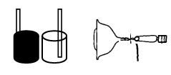
Time  (min) | Black Can  (°C) | Silver Can  (°C)
0
5
10
15
20
Total
Change

Graph Your Results: Create a line graph for the data table above.
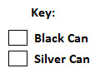
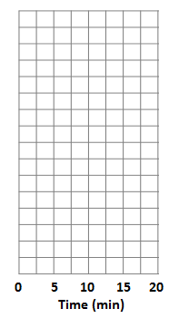

Temperature (°C)
5 10 15 20 25 30 35 40

1. Which color can had the greatest temperature change? ______________________

- What type of heat transfer does this best represent? ____________________________

  - Why? ____________________________________________________________
_________________________________________________________________

Station #4

Fill Cup A with hot water, fill Cup B with cold water. Cover both cups with the Styrofoam insert, consisting of an aluminum bar and thermometer. Record the temperature change for each cup on the data table below.
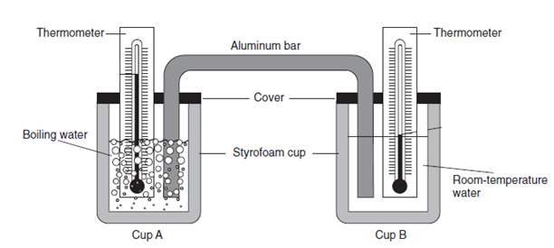

Data Table

Time  (min) | Cup A  (°C) | Cup B  (°C)
0
5
10
15
20
Total
Change

Graph Your Results: Create a line graph for the data table above.

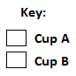

Temperature (°C)
10 20 30 40 50 60 70 80 90

- What happened to the temperature of the water in Cup A, after 20 minutes? _________
________________________________________________________________________

- Why? ___________________________________________________________
_______________________________________________________________

- What happened to the temperature of the water in Cup B, after 20 minutes? ________
________________________________________________________________________

- Why? ____________________________________________________________
_______________________________________________________________

- What type of heat transfer does this best represent? ____________________________

  - Why? _____________________________________________________________
__________________________________________________________________

Analysis:

- Heat always moves from __________________ objects to _________________ objects.

- Why do hot fluids rise? ____________________________________________________
________________________________________________________________________________________________________________________________________________

- Why do cool fluids sink? ___________________________________________________
________________________________________________________________________________________________________________________________________________

- What type of heat transfer do the following best describe: conduction, convection or radiation

_________________________ a. A bar of chocolate left in the sun begins to melt.

_________________________ b. An egg is frying in a pan on a hot electric stove.

_________________________ c. Air above a warm beach rises and cooler air from the
ocean moves inland to replace it.
_________________________ d. A damp cool washcloth is placed on the forehead of a
child with a fever.
_________________________ e. Continental plate shifting.

_________________________ f. A cold table slowly warms as you keep your hand on it.

