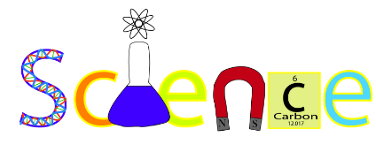

Expectations & Procedures

Mrs. Edie Fulton
Email: efulton@southseneca.org
Telephone: 607-869-9636 ext. 1248

Welcome to Science 7! This year is the first year, of a two year curriculum, that will conclude with the NYS assessment at the end of 8th grade. Taken together, the two years are a survey of life science, earth science, chemical and physical sciences, which previews and sets the stage for high school-level courses in biology, earth science, chemistry, and physics.
Mrs. Fulton’s Website
(http://fultone.weebly.com)

I have created a website that I invite you to visit often and save to your favorite. This website contains all of my unit information, links to other websites, a calendar of important dates and parent resources. If ever you have a question about work your student is currently working on, I ask you please visit my website for guidance and helpful information.

Grading Procedures

Quarterly Averages:
(80% of Overall Grade)
- Daily Assessments – 10%

Labs & Projects - 20%

Topic Assessments - 35%
- Unit Assessments - 35%

Cumulative Final:
(20% of the Overall Grade)

Class Rules
- Be in your seat, on time, and ready to learn!
- Have needed materials with you daily.
- Participate in class discussions and activities.
- Be positive!

Materials
- 3” – Three-ring binder with eight tab dividers:
- Pens (black or blue ink ONLY!)
and pencils
- Chromebook – charged!!!!!
- Homework accordion folder/Trapper Keeper

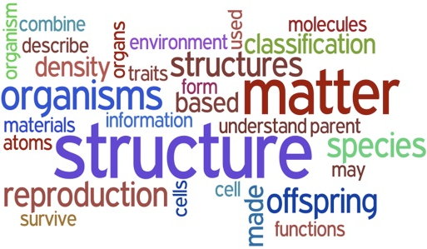

Email Updates
The 7th Grade Team uses an email address bank, to communicate information with parents. When individual teachers, or the Team as a whole, need to inform you of upcoming events or important dates we will use this format of communication. This also helps us in contacting you as individual circumstances arise. If your email address changes and you still wish to be on the email list, we ask that you inform us of the change.

Science 7 - Learning Goals

Unit I – Measurement & Analysis
- The Scientific Method
- Metric System
- Analysis & Inquiry

Unit II – The Nature of Life
- The Microscope
II. Characteristics & Needs of Living Things
III. Classification

Unit III – The Living Environment
- Cell Theory
- Cell Structures & Functions
- Cell Processes

Unit IV – Systems: Organ Systems, Skeletal, Muscular & Digestive
- Organ Systems
- Skeletal System
- Muscular System
- Digestive System

Unit V – Systems: Circulatory, Respiratory & Excretory
- Circulatory System
- Respiratory System
- Excretory System

Unit VI – Systems: Nervous, Endocrine & Immune
- Nervous System
- Endocrine System
- Immune System

Unit VII – Reproduction & Genetics
- Reproductive System
- Genetics

Unit VIII – Ecology
I. Changes in Living Things Over Time
II. Interactions Among Living Things
- Cycles in Nature
- Earth’s Biomes
***Sign and Return
this Page ONLY!***

Science 7
Expectations & Procedures

Please sign and return this sheet only to Mrs. Fulton indicating that you, the parent/guardian, have read and understand the above information. Please keep the rest
of the papers in case you ever have any questions or concerns regarding the grading policy/procedures for Science.

_______________________________________________
(Printed Student Name)

_______________________________________________
(Parent/Guardian Signature)

_______________________________________________
(Parent Email Address)

Thank you and I look forward to a great two years with your student!

Edie Fulton
Science 7&8

