Name ________________________________________ Date ___________ Block ___________

Electricity & Magnetism
Lab

- Electricity

Electrical energy is produced by moving electric charges. These electric charges are caused by the loss or gain of electrons from the orbits of an atom, ions. If an atom loses an electron it is said to be positively charged (+) due to having a greater number of protons than electrons. If an atom gains an electron it is said to be negatively charged (-) due to having fewer protons than electrons.

Analysis:
- How is electrical energy produced? ____________________________________
_________________________________________________________________

- What causes these electric charges? ____________________________________
__________________________________________________________________

- Why does the loss of an electron cause an atom to be positively charged? _____
__________________________________________________________________

- If an atom has fewer protons than electrons it is said to be: _________________

Making Connections: Use the diagrams to identify if the atom is a positive ion or a negative ion, how many protons and electrons would each atom contain on both sides.
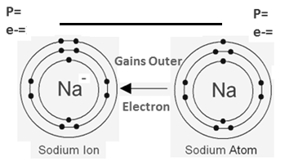

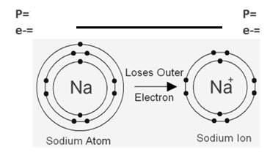

The difference between the two charges, + and -, cause them to have different forces; attraction and repulsion. The Rule of Electric Charge states: Like charges repel and opposite charges attract. Electric charges always travel from positive charges to negative charges and must have a closed circuit for the electrons to flow through. There are two types of circuits electrons can travel through; series circuits and parallel circuits. Series circuits provide just one path for electrons to travel and if at any point the path is broken the whole circuit stops. Parallel circuits provide multiple paths for the electrons to travel and if at any point one path is broken the electrons can still travel freely through the other paths.

Analysis:
- What does the Rule of Electric Charge state? _____________________________
__________________________________________________________________

- Electric charges always travel from _____________ charges to _____________ charges.
- A house wired for each room to turn on and off separately would be an example of this type of circuit: ________________________________________________

- Christmas lights are an example of this type of circuit: ______________________

Making Connections: Use the diagrams below to answer the questions that follow.
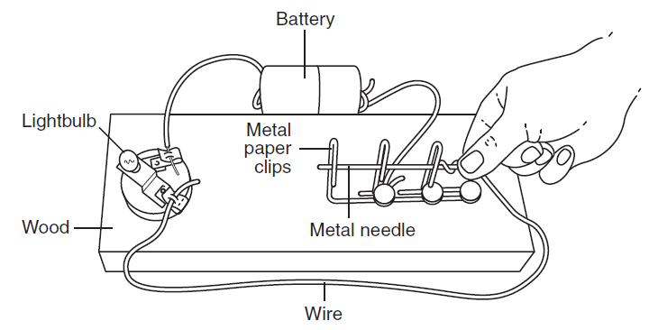

- What type of circuit is pictured above? __________________________________

- Would the light bulb turn on with the situation as it currently appears? ________

  - Why? _______________________________________________________

Practicing with Electricity

- Create the set-up below and use each of the following materials, at location B, to determine if the light bulb will light or not and if the material would be considered a conductor or insulator.
Conductors: Any material that permits the flow of electric charges freely.
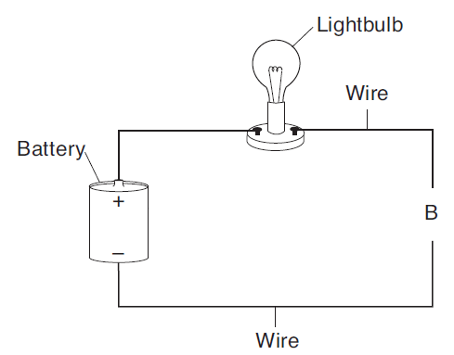
Insulators: Any material that does not permit the flow of electric charges freely.

Material | Lights Light Bulb? | Conductor/Insulator
Paperclip
Toothpick
Eraser
Copper wire
Penny
Aluminum foil
Plastic chip

- Create the set-up below:
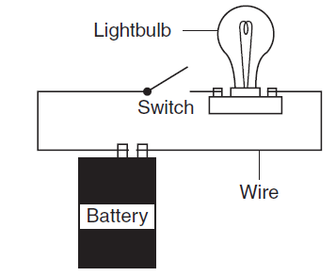

- What type of circuit is this an example of? _______________________________

  - With the switch up, does the light turn on? ________________________

    - What does putting the switch down do to the circuit? __________
______________________________________________________

- Create the set-up below:
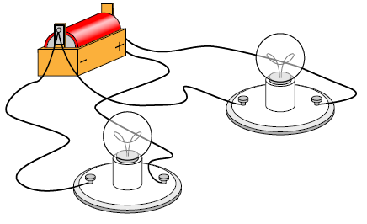

- What type of circuit is this an example of? _______________________________

  - If you unhook one light from the battery does it turn off the second light?
____________________________________________________________

- Magnetism

More than 2000 years ago, Greeks living in Magnesia discovered a rock with an unusual trait; it attracted materials that contain iron. They named this rock magnetite. They also found that when this rock was hung freely from a string the same end of the rock would always point toward the north start, leading star or lodestar. Magnetite is also referred to as Lodestone due to this.
What the Greeks had identified is a characteristic called magnetism, the invisible force of attraction or repulsion of a magnetic material due to the arrangement of its atoms. All matter is made of atoms. Atoms are composed of protons (p), neutrons (n) and electrons (e-). The electrons, in the outer orbits, are in constant motion and spin causing a magnetic field. Those materials with random motions of the electrons are called nonmetals and do not have magnetic properties. Those materials that have their electrons all pointing in the same direction, magnetic domain, have magnetic properties.

Analysis:
- Define magnetism: _____________________________________________________
_____________________________________________________________________

- Another name for magnetite is: ___________________________________________
  - Why? _____________________________________________________________
__________________________________________________________________

- Define magnetic domain: _______________________________________________
_____________________________________________________________________

- Label the diagrams below as No Magnetic Domain and Magnetic Domain:

  - _______________ b. ________________

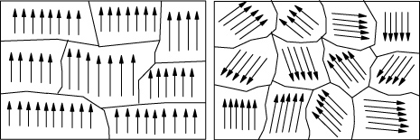

All magnets have two ends where magnetic effects are strongest, poles. These poles are called north and south. Magnetic forces are strongest at the poles and move from the north pole of the magnet to the south. Just like electric forces, magnetic forces follow the same rule: opposite forces attract and like forces repel.

Analysis:

- Where are magnetic forces the strongest? __________________________________

- What does the rule of magnetic forces state? ________________________________
_____________________________________________________________________

- Label the diagram below with attract and repel.

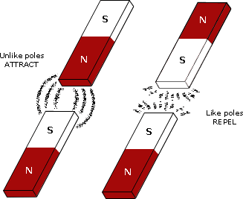

_____ 4. Which diagram below would show magnets with the strongest force of
attraction between them?
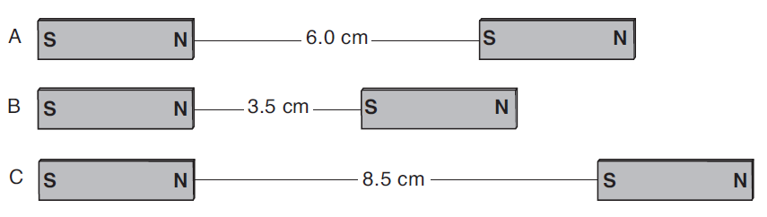

Magnets also have magnetic fields, lines of force extending from one pole of a magnet to the other. This magnetic field is the area over which the magnetic force is exerted. Magnetic lines of force always move from the north pole of the magnet to the south pole.

Analysis:

- Define magnetic field: __________________________________________________
_____________________________________________________________________

- Magnetic lines of force always move from: __________________________________

On the diagram below, fill in the direction of magnetic forces.
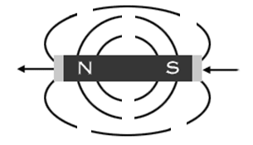

Fill in the diagram correctly with N or S depending on the type of magnetic force
being shown.
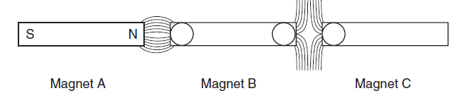

Practicing with Magnets

      - Magnetic Field

- Place the horseshoe magnet, on its side, on top of the iron filings.
- Draw the lines of magnetic force on the diagram below.

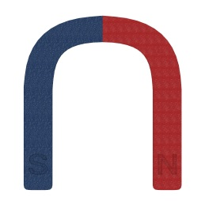

- Place two magnets on the table, as shown below.
2. Place the petri dish containing iron filings on top of the magnets.
- Draw the lines of magnetic force on the diagram below.

  - Place two magnets on the table, as shown below.
  - Place the petri dish containing iron filings on top of the magnets.
  - Draw the lines of magnetic force on the diagram below.

- Using your pencil, place two ring magnets on it so that it looks like the diagram below.
  - Label the poles correctly as to how the magnets would be positioned.
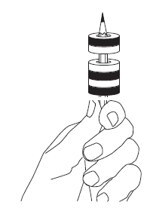
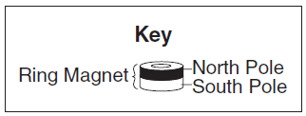
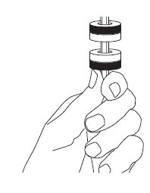
- B.

