Name ______________________________________________ Date ________ Block ________

Unit I
Chemical Interactions
Review Sheet

- Introduction to Matter – (Notebook pages 1-6)

- Define:
  - Matter
  - Element
  - Compound
  - Solution
  - Solid
  - Liquid
  - Gas
- What are the properties of matter?
- What does a chemical change alter?
- What does a physical change alter?
- In this change you cannot get the original substance back:
- In this change you can get the original substance back:
- What are two kinds of pure substances?
- What are two kinds of mixtures?
- Is this an example of a physical (P) or chemical (C) change:
  - Digesting food
  - Burning a match
  - A car rusting
  - Mixing sugar in ice tea
  - Tearing a piece of paper
  - Baking bread
  - Crushing a can
- Blood is an example of a:
- CO₂ is an example of a:
- O₂ is an example of a:
- Salt Water is an example of a:
- Na is an example of a:
- Solid, Liquid or Gas
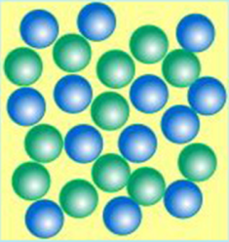
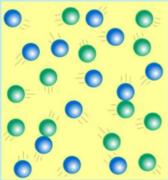
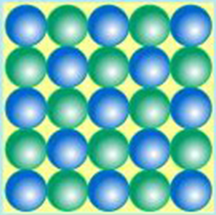

- Particles of Matter – (Notebook pages 7-13 & 16)

- Define:
  - Proton
  - Neutron
  - Electron
  - Atom
  - Atomic Number
  - Atomic Mass
- How many electrons can the 1st orbit hold?
- How many electrons can the 2nd orbit hold?
- How many electrons can the 3rd orbit hold?
- Protons are always equal to:
- The nobel gases are located in this group:
- Groups are located where on the periodic table?
- Periods are located where on the periodic table?
- What are the characteristics of metals?
- What are the characteristics of nonmetals?

- Use the periodic table to answer the following questions:
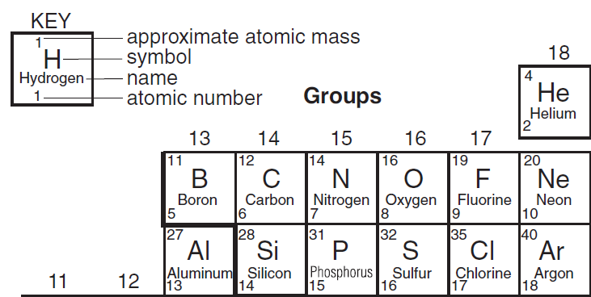

  - What is the atomic number of Argon?
  - What is the atomic mass of Boron?
  - What is the element symbol for Hydrogen?
  - What is the element name for Si?
- Complete the chart
(p+n)
(p=e-)

Element Atomic # Atomic Mass p n e-

Sulfur 16 _______ _____ 16 _____

Phosphorus _____ 31 15 _____ 15

- Electron Dot Configuration

Carbon p = _____ Diagram
Atomic Number = 6 n = _____
Atomic Mass = 12 e- = _____

Hydrogen p = _____ Diagram
Atomic Number = 1 n = _____
Atomic Mass = 1 e- = _____

Acids and Bases – (Notebook pages 17-20)

- Define:
  - Indicator
  - Hydrogen Ion
  - Acid
  - Hydroxide Ion
  - Base
- What are the characteristics of acids?
- What are the characteristics of bases?
- What do chemists use to measure the concentration of hydrogen ions in a solution with?
- What color does cabbage turn when in the presence of:
  - Acids:
  - Bases:
- What substance has a pH of 7 and is considered neutral?
- Define:
  - Solute
  - Solvent

- Short Answer Essay
- Use each diagram to answer each of the bullets that follow:

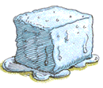
1.
  - What phase change is being shown?
  - What state changes are taking place?
  - Is heat being released or absorbed?

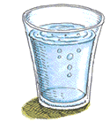
2.
  - What phase change is being shown?
  - What state changes are taking place?
  - Is heat being released or absorbed?
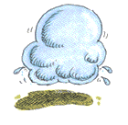
3.
  - What phase change is being shown?
  - What state changes are taking place?
  - Is heat being released or absorbed?

- pH Scale
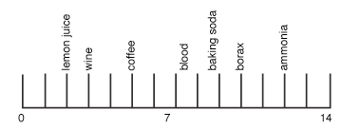

- Label the pH scale correctly with acid, base, neutral
- What is the approximate pH of:
  - Lemon juice
  - Wine
  - Coffee
  - Blood
  - Baking soda
  - Borax
  - ammonia

