Name ___________________________________________ Date _________ Block __________

Cell Structure & Function

In the late 1600’s when Robert Hooke named the “cell”, he was looking at an empty space in the cork cells. Over the next 150 years scientists became aware that cells in living things were not empty at all.

In the middle 1800’s two German scientists, Schleiden and Schwann presented their Cell Theory. It stated that all living things are made up of cells, cells are the basic structure and function of all living things, and all cells are produced by other cells.

There are two types of cells that make up all living things; prokaryotic cells and eukaryotic cells. Prokaryotic cells have no true nucleus, no membrane bound organelles and are single celled organisms like bacteria and archaebacteria. Eukaryotic cells have a nucleus and membrane bound organelles. These cells are usually large and complex and are found in multicellular organisms.

Analysis:
- What are the three statements that make up the cell theory?
  - __________________________________________________________________

  - __________________________________________________________________
__________________________________________________________________

  - __________________________________________________________________

- Identify the type of cell each diagram below represents: Prokaryote or Eukaryote
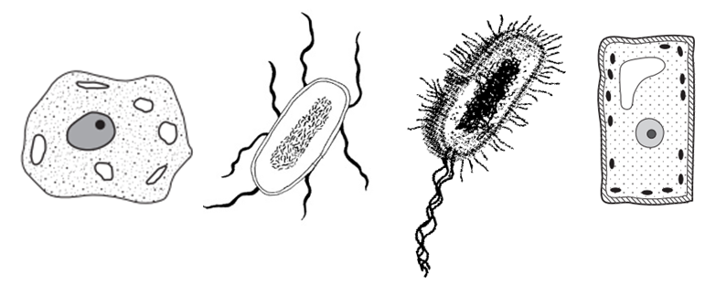

  - ___________ b. ___________ c. ___________ d. ___________

- What characteristic makes prokaryotic cells different from eukaryotic cells? __________
________________________________________________________________________

Two types of Eukaryotic cells are; plant cells and animal cells. Both are made up of smaller parts called organelles, tiny cell structures that carry out specific functions within the cell “little organs”. The easiest way to distinguish a plant cell from an animal cell is by the shape; plant cells look like a box or square and animal cells are round.

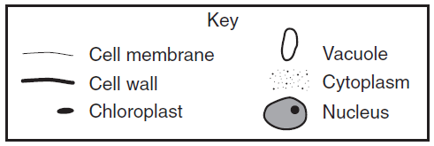

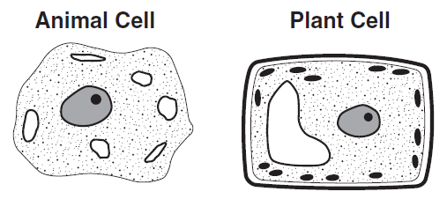

Organelle | Function
Cell Membrane | Selectively permeable; controls what comes into and out of the cell.
Cytoplasm | Watery substance that fills the cells and moves needed materials around.
Nucleus | Control center of the cell – contains chromosomes (X).
Chromosome | Located inside the nucleus; made up of genetic information called DNA.
Mitochondria | Powerhouse of the cell – energy is produced here through respiration.
Cell Wall | Stiff, rigid structure that supports and protects plant cells ONLY
Vacuole | Storage site of water and wastes.
Chloroplasts | Site of photosynthesis in plants where sunlight is converted into energy.

Analysis:
- Define Organelle: _________________________________________________________
________________________________________________________________________

- If you were given an unknown cell, what would you look for first to identify it? _______
_______________________________________________________________________

- Name two organelles that are found ONLY in plant cells:
  - ________________________________________________________________
  - ________________________________________________________________

- If a plant was wilting, what organelle would not be working correctly? ______________

- What organelle does a plant use to keep it standing upright? _____________________

- Which organelle is the site of photosynthesis? __________________________________

- Which organelle contains genetic material, chromosomes (X)? _________________________

The Cell Membrane is a selectively permeable tissue that surrounds the cell and its organelles. It allows only certain substances to enter or exit the cytoplasm and therefore acts as a “gateway” between the outside and inside environments.
In order for a cell to maintain a healthy environment it must constantly bring in needed materials while removing waste products. Two processes are used to transport these materials into and out of the cell; diffusion and osmosis.
Diffusion is the movement of particles from areas of high concentration to areas of low. These particles could be oxygen, carbon dioxide or nutrients. Osmosis is the movement of water from areas of high concentration to areas of low.
Osmosis and Diffusion do not require energy for the cell to move substances from areas of high concentration to areas of low. When no energy is required it is called Passive Transport. When energy IS required the process is called Active Transport. The molecules being transported by either passive or active transport will continue to move until their concentrations have reached equilibrium, the state where equal numbers occur on both sides of the cell membrane.
All molecules travel in a solution, a mixture of two or more substances. The solvent is the part of the solution doing the dissolving, water is the universal solvent. The solute is what is being dissolved in a solution. In a cell the solute is usually oxygen, nutrients or carbon dioxide.

Analysis:

- Matching – Put the letter of the correct answer in the space provided.
_____ 1. Selectively Permeable A. The movement of materials through a cell membrane
using energy.
_____ 2. Diffusion B. The movement of water from areas of high concentration
to areas of low.
_____ 3. Osmosis C. The ability for only some substances to move in or out
of a cell.
_____ 4. Passive Transport D. The movement of materials through a cell membrane
without using energy.
_____ 5. Active Transport E. The movement of particles from areas of high
concentration to areas of low.
- Multiple Choice – Put the letter of the correct answer in the space provided.
_____ 6. Which substance is the cell membrane usually NOT permeable to?
a. water b. carbon dioxide c. blood cells d. oxygen

_____ 7. Which of the following is an example of Passive Transport?
- osmosis b. diffusion c. digestion d. both A & B

_____ 8. The substance in a solution that does the dissolving:
- solvent b. equilibrium c. solute d. concentration

_____ 10. Particles in a solution will continue to collide and spread out until this is reached:
- equilibrium b. concentration c. diffusion d. solvent

- Making Connections – Use the diagrams to answer the questions that follow.
Water –
Sugar -
_____ 11. Which substance in the solution would be the
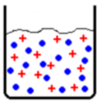
solvent?
- water b. sugar c. both

_____ 12. Which part of the solution would the sugar be?
- solvent b. solute c. concentration

- Active Transport B. Diffusion C. Osmosis
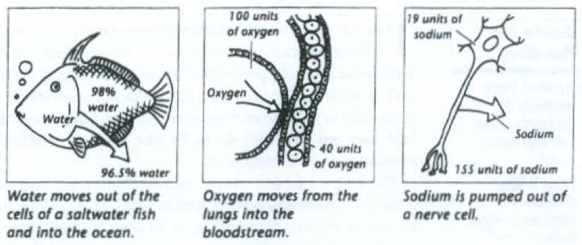

13. _________ 14. _________ 15. _________

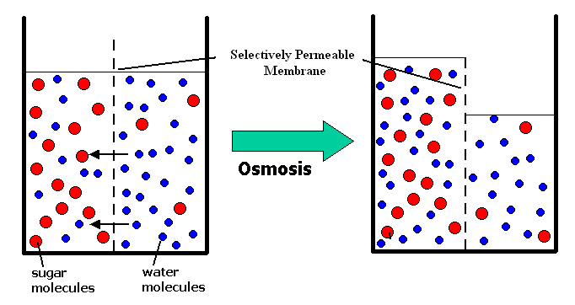

16. What organelle in a cell does the selectively permeable membrane best represent?

17. Which molecule is able to move through this membrane?

- What process does this best represent?

18. In the diagram to the right, what state has been finally reached with the water molecules?

The lifespan of a cell depends on the type of cell it is and what its job is. In the average human body there are roughly 10 trillion cells and 200 different types of cells. Every minute, an average of 300 million of the body’s cells die.

Cell Type | Lifespan
White Blood Cell | Few hours to a day
Liver Cell | 8-16 months
Taste Receptor | 10 days
Nerve Cell | Lifetime
Skin | 1 month
Muscle Cell | 15 years
Red Blood Cell | 3 months

Analysis:
- What type of cell has the longest lifespan? _____________________________________

- Which cell type only lives for less than a day? ___________________________________

The formation of new cells is essential for an organism to grow, develop and repair damaged parts. The process by which one cell divided into two cells is called Cell Division. When body cells make new copies of themselves they use a process called Mitosis, “my toes”. When sex cells make new cells they use a process called Meiosis, “me”. The stages of mitosis are as follows: Interphase (the longest stage of cell division), Prophase (mitosis begins!), Metaphase, Anaphase, Telophase (last stage of Mitosis) and Cytokinesis (the final stage of the cell cycle). The easiest way to remember the order of mitosis is by the first letter of each stage name, IPMAT.
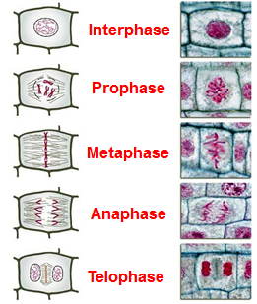

Analysis:

- Matching – Put the letter of the correct answer in the space provided.

_____ 1. Cell Division A. Genetic information passed on to new cells (X).

_____ 2. Mitosis B. Cell division process that takes place in sex cells.

_____ 3. Daughter Cell C. The process by which one cell divides into two cells.

_____ 4. Chromosome D. Cell division process that takes place in body cells.

_____ 5. Meiosis E. The new cells created after cell division occurs.

- True or False – Write True if the statement is true. If the statement is false, change the underlined word or words to make the statement correct.

_____ 6. The longest stage of the cell cycle – Interphase.

_____ 7. The final stage of the cell cycle – metaphase.

_____ 8. Mitosis begins during Anaphase.

_____ 9. The last stage of mitosis is Telophase.

_____ 10. IPMAT are the letters to remember the order of cell division.

- Matching – Put the letter of the correct answer in the space provided.
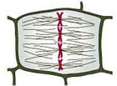
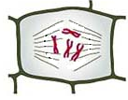
_____ 11. Interphase A. B.

_____ 12. Prophase

_____ 13. Metaphase
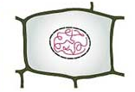
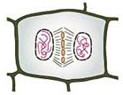
C. D.
_____ 14. Anaphase

_____ 15. Telophase

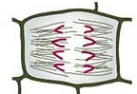
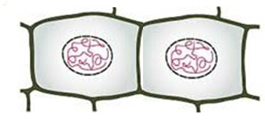
_____ 16. Cytokinesis E. F.

